  - DELIVERABLE 5.2
  - AUGUST 2020

Facilitating the Authorisation of Preparation Process for blood, tissues and cells
  - Report on the outcome and conclusions of the survey, desk-based review of preparation process authorisations in other fields and the multi-country workshop
Date of submission: | XX.XX.2020
Work package: | WP5
Author(s): | HPRA AND OCATT (CATSALUT)
Dissemination level: | Draft of a public report
Contents
Background 2
Introduction 3
I. Survey 4
II. Desk-Based Review 5
III. Multi-Country Workshop 8
1. Part A - Risk Assessment 9
New / Novel Processes 18
2. Part B - Application Process 20
Changes to existing processes (variations) 24
3. Part D 26
Review and Evaluation 26
Authorisation 31
Conditional Authorisation 33
4. Part E - Framework of Competent Authority 34
IV. Discussion and conclusions 39
Appendix 1 – GAPP Work Package 5 Survey Results: 42
Appendix 2 - Bibliography 51
Appendix 3 Acronyms 55

Background
The purpose of WP5 is to develop guidance on how a preparation process authorisation (PPA) programme should or could be organised. In order to develop the guideline, WP5 will elaborate on the good practice guidelines for PPA based on the requirements defined in the European Directives, and review and analyse outputs from previous projects in order to define a common approach and methodology.
There are three main milestones for WP5:

D.5.1 Extension of the outputs of previous projects, VISTART¹ WP5B, EUROGTP II etc., to be applicable to blood establishments.

- The HPRA and OCATT have performed a review of the outputs of VISTART WP5B and
of EUROGTPII and a report has been drafted.

- The EUROGTPII group have been approached to review if EUROGTPII can be extended to blood. The practicalities of how this would be performed and what the expectations would be in this regard are yet to be discussed.

D 5.2 Report on the outcome and conclusions of the survey, the desk-based review of PPA in other fields and the multi-country workshop

- Desk Based Review:

The desk-based review has been completed by the HPRA. The methodology and relevant results of the review will be discussed in this report.

- Survey:

The survey was completed in 2019, findings will be discussed in this report, and results relating to other WPs have been provided to the appropriate contacts.

- Multi Country Workshops:

A multi-country workshop was held for tissue and cell CAs in October 2019, and again for blood CAs in February 2020 at the European Commission Office’s in Brussels. The survey results and proposed guidelines were discussed.

- D. 5.3 Good practice guideline to authorisation on preparation processes in blood, tissues and cells (M32).

The report from D.5.1 and D.5.2 will provide a basis for the guidelines.

The guidelines will consider two aspects;

- Requirements for CA’s in managing an effective PPA system (personnel, use of experts, organisational framework etc.);
- Common methodology for managing PPA (for both CA’s and Blood / Tissue Establishments) from application to authorisation;

The guidelines will incorporate the outputs from the technical WPs 6, 7 and 8. In addition, the guidelines will take into account the proposed database in relation to WP9;

Introduction

The concept of a preparation process authorisation (PPA) is not a new one, the PPA or the preparation process dossier (PPD) is discussed in:
- Directive 2006/86/EC – Annex II
- ‘Inspection of tissue and cells procurement and tissue establishments operational manual for Competent Authorities’
- VISTART WP6 – ‘Inspection guidelines for EU Competent Authorities responsible for the inspection and authorisation of blood and tissue establishments’

The preparation process dossier templates in both the manual and the guidelines have the same common format: establishment information; preparation process-general information; materials and equipment; quality control testing; process validation for tissues and cells; process validation for blood or blood components; final labelling and accompanying information; signature and date; and each CA will insert relevant instructions for submission.
The guidelines and the operation manual recommend that CAs adopt or adapt the PPD template provided, and thoroughly evaluate this prior to granting an authorisation to process a blood, tissue or cell product.
To aid with the development of the PPA guidance:
- a survey was developed and circulated to Competent Authorities to gain an understanding of existing PPA systems that may already be in place
- a desk based review was conducted of product authorisation systems in place in other relevant sectors e.g. medicines, medical devices
- multi-country workshops were organised for blood, and tissue and cells Competent Authorities to discuss the PPA programme
The outcomes of the activities above, in conjunction with relevant outputs from previous European projects, will be discussed throughout this document, as relevant. However a specific report in relation to the review of previous projects has also been produced. Ref: Deliverable 5.1 ‘Extension of the outputs of previous projects, VISTART WP5B, EUROGTPII, to be applicable to blood’.

I. Survey

A survey was devised based on a number of areas, which were deemed beneficial to the development of guidance on PPA, while also taking into account other projects which had taken place, such as EuroGTPII.
The survey was divided into 3 different sections, as indicated in table 1 below, and sent to all blood, and tissues and cells CA, including those responsible for medically assisted reproduction (MAR).
The survey results are detailed in appendix A of this report. A number of questions were included on behalf of the other work packages and these will not be discussed, the results have been made available to the relevant work package leaders.
Section 1: Framework for Authorisation at Competent Authorities
This section aimed to gather information on the scope and type of authorisations granted in the MS, the management of changes to existing authorisations and the management of new or novel applications for authorisation.

Section 2: System for Preparation Process Authorisation (PPA):
This Section aimed to gather information on the application processes in place across MS CA, how these applications are risk assessed and the technical requirements included within the application for authorisation including;
- Authorisation of changes to activities performed by blood and tissue establishments (Work Package 6);
- Assessing the quality and safety of donor testing, microbial inactivation and sterilisation steps as part of PPA (Work Package 7);
- Assessing Clinical data as part of PPA (Work Package 8);

Section 3: Review and Authorisation
This section aimed to gather information on the systems in place for the review and evaluation of data submitted in support of applications for authorisation, the personnel / experts involved in the review process and the system for the approval / refusal of authorisation applications.

Table 1: Survey sections

II. Desk-Based Review
It was initially envisioned that the guidance document would take the following format, as such, this format was incorporated within the design of the desk-based review:
Chapter 1: Framework for Authorisation at Competent Authorities
What is required at a CA to implement and manage a PPA system, including;
- Organisational Models and mandates of CA;
- Optimal Composition of Assessment Team;
- Guidance given to BE/TE relating to PPA;
Chapter 2: Preparation Process Authorisation (PPA) - Application:
Application Process, including terms and timing of application; for;
- Changes to existing processes;
(Including definition of what substantial / significant changes require application for change in the PPA)
- New / Novel Processes;
What risk assessment should be performed? (EUROGTPII / Others etc. application of Risk Assessment)
What information / documentation is required to be provided in support of the application?
What technical aspects are to be considered (Link to Technical Work Packages) and provided in support of the application?
- Authorisation of changes to activities performed by blood and tissue establishments (Work Package 6);
Critical Process Parameters and Critical Quality Attributes – Extent of Validation;
- Assessing the quality and safety of donor testing, microbial inactivation and sterilisation steps as part of PPA (Work Package 7);
- Assessing Clinical data as part of PPA (Work Package 8);
Chapter 3: Preparation Process Authorisation (PPA) - Review and Authorisation
What review and evaluation should be performed over data submitted in support of applications for authorisation? – Link to inspection systems
Define a system for the approval / refusal of authorisation applications;
Define the scope and type of authorisations (Full / temporary / conditional);
Maintenance and Management of PPA
Appendices:
Process Flow from Application to Authorisation – Including actions to be taken at each step of the process – Defined Sequential Approach
Template Application Form?
Template PPA;
Table 2: Initial Proposal for PPA Guidance Document
Below (table 3) are the questions used to evaluate the PPA frameworks in the different sectors alongside the relevant chapter of the proposed guidelines to which the question relate.
The framework for PPA in Medical Devices, Medicinal products, ATMP’s, Herbal and Homeopathic were reviewed against this common set of criteria / questions and the outcomes are discussed in this document.

The documents reviewed in relation to the PPA frameworks are included within Appendix 2 – Bibliography

Desk-Based Review
- Does the CA maintain a dossier that describes the details of the preparation / manufacturing process (i.e. a preparation process authorisation) – Chapter 1 (system at CA) and Chapter 3 (management and maintenance of PPA)
- Are there defined procedures in relation to risk assessment or risk categorisation, if so:

  - Are these procedures commonly defined at a European level, e.g. (EU Directives, EMA procedures, ISO or ICH procedures) or are they otherwise defined by professional associations or bodies? – (Chapter 2 risk assessment)

  - Are the risk categories comparable to those defined by EUROGTP II and where could they be considered to be aligned? – (Chapter 2 risk assessment)

  - Is there a system for risk categorisation or grading of changes in processes which links to specific requirements in relation to regulatory approval of the change? – (Chapter 2 risk assessment)
- Is there a specific set of documents which provide guidance to applicants (Chapter 1) on:

- What data is required to support an authorisation and how that data is to be presented? – (Chapter 2 information to be submitted in support of application)

- Is there specific guidance in relation to the definition of the following specific aspects? – `(Chapter 2 information to be submitted in support of application)

a. Control of starting materials
b. Critical Processing Parameters (CPPs) and their control
c. Process validation
d. Product Characterisation / Critical Quality Attributes (CQAs) and the relationship to CPPs.
e. Justification of specifications
f. Development studies
g. Microbiological attributes
h. Clinical efficacy
i. Clinical safety
j. Storage requirements

- The scope or extent of clinical evaluation studies or trials required to be performed in support of authorisation? – (Chapter 2 clinical evaluation)

- If there is guidance on the scope and extent of clinical evaluation studies or trials, is it risk based and related to a categorisation of the product? – (Chapter 2 clinical evaluation)

- Does the framework have a provision for the conditional or provisional authorisation of the relevant product? if so: - (Chapter 3 scope of authorisation)

    - What are the circumstances in which such an authorisation can be granted?
    - What are the requirements for subsequent follow-up monitoring?
- Is there a specific set of documents, relevant to the framework, which provide guidance in relation to ‘good clinical practices’ required to ensure the validity and acceptability of clinical data collected and submitted in support of a product authorisation? – (Chapter 2 clinical evaluation and Chapter 3 review and evaluation)
- Is there a specific set of documents which provide guidance to competent authorities or other relevant bodies (e.g. notified bodies) in relation to the review/assessment of the data to be submitted to support a product authorisation?, if so: - review and evaluation

- Does the guidance include:
- A defined sequential approach to the review of data?
- Identification and evaluation of ‘checkpoints’ critical to the product approval?
- Defined algorithms for the evaluation of data submitted in support of an authorisation?

- Does the review process involve the use of any computer based systems for the evaluation of submitted data by using defined algorithms or in any other way? – (Chapter 3 review and evaluation and appendices)

- Does the guidance (or relevant legislation) define any minimum requirements for the qualification of personnel involved at various levels in the review /assessment process? – (Chapter 1 system at CA)

- Does the guidance (or relevant legislation) provide for, or mandate, the use of external (third party) experts or expert panels at either a national or supra national level? – (Chapter 1 system at CA)

- If so, are qualification criteria etc. defined and in the case of a panel of experts is the composition of such a panel defined?
- Does the framework provide for information sharing at an international level in order to support review / assessment of applications for authorisation and, if so, how is this facilitated? – (Chapter 3 review and evaluation)
- Is there a defined format for the sharing of information in such cases?

- Is there a mutually accessible database of national authorisations or details of the associated review / assessment, if so, what level of information is contained in the database?
- Are any case studies / training materials available to demonstrate the risk categorisation and the subsequent requirements for review / assessment? - (Chapter 2 risk assessment and Chapter 3 review and evaluation)

- Are there specific aspects of the framework which could be considered to be relevant or proportionate to the development of a framework for the authorisation of preparation processes for: - (Chapter 1 system at CA; Chapter 2 risk assessment; Chapter 3 review and evaluation
  - blood
  - tissues and cells
  - HPSC
  - ART (MAR)
Table 3: Desk-Based Review Questions

III. Multi-Country Workshop
Two multi country workshops were carried out, one for tissue and cell CAs, and one for blood CAs. The purpose of the multi country workshops were:
- to promote discussion to consider and gather information on the status of Preparation Process Authorisation (PPA) systems
- to further explore organisational and procedural models identified by the survey and to identify strengths, weaknesses and best practices

Methodology for Workshop
To facilitate discussions the 5 key headings, as follows, which were considered relevant to the development of the framework, and which can be considered to encompass the lifecycle of the authorisation process were worked through:
Part A – Risk Assessment
Part B – Application Process
Part C – Framework for Competent Authority
Part D – Review and Evaluation
Part E – Authorisation
Table 4: Workshop Discussion headings
In relation to each of these headings, the findings from the survey were presented and pertinent regulatory processes highlighted which are in place in other sectors, with a view to promoting discussion and gathering further information on the relevant structures, frameworks, procedures, guidance etc. in place at the MS CAs;
Following discussion from the multi country workshop the headings above were adjusted for the PPA guidance and a new template was proposed (table 5). The information in this report will be discussed in as close as possible to the order of the appropriate sections, as the information allows.
The new proposed format is as follows:
Part A
Risk Assessment
- Definition of novelty
- Significant changes
Part B
Application Process
- New application
Modules 1 -5
(1: Admin information; experts involved in compilation of the dossier; labelling; leaflet.
2: characterisation of the blood/ tissue/cell; quality overview; non clinical overview; clinical overview; risk benefit evaluation; clinical follow up; clinical investigation plan.
3: Composition of blood/tissue/cell; donor selection and testing; preparation process; validation and stability; quality control.
4: non-clinical study report.
5: clinical study report)
- Variations
Part C
Technical Annexes
Part D
- Review and evaluation
- Authorisation
Part E
Framework of Competent Authority
Table 5: New proposed guideline template

Part A - Risk Assessment

Risk assessment - WP5 Survey
The survey results indicated that 75% (15/20) of respondents specified that there was no risk categorisation system in place for application of changes to existing applications / or applications for authorisation of new or novel activities, products, processes or clinical indications. With 25% (5/20) indicating that there was a risk categorisation system in place for the application of changes to existing authorisation, with 2 of the same CAs indicating that there was also a system in place for applications for authorisation of new / novel activities, products, processes, or clinical indications. The question was also asked as to whether the outcome of the risk assessment determined specific requirements for approval of the application, 21% (4/19) indicated yes, 16% (3/19) indicated no and 63% (12/19) indicated that it was not applicable.
In addition 63% (10/16) of CA’s who replied to the survey did not currently intend to use the EUROGTPII tool as a basis for risk assessment in the regulatory context. With 23% (3/13), indicating that the risk categories defined in EUROGTPII were comparable with the categories within their CA. The risk categories aligned were with regards to characterisation of the process and ethical principles and considerations.
Based on the feedback received from the survey, it was evident that there was no current widespread use of risk categorisation at CA level. The lack of widespread use of risk categorisation at CA level perhaps highlights a lack of familiarity at CA level with the EUROGTP II tool. This could indicate a requirement for further targeted training of inspectors / assessors.

Risk assessment - Desk-Based Review
Medical Devices
Annex VIII of the Medical Devices Regulation (EU) 2017/745³⁷ outlines the classification rules for medical devices. Devices can be classified into four risk groups; Class I, IIa, IIb and III. Class I represents the lowest risk, Class III is the highest. There are 22 rules for determining the classification of a device; these are described in Chapter III of Annex VIII.
Chapter II of Annex VIII provides guidance on implementing the classification rules. There are a number of factors to be considered when implementing the classification rules, including:
- Application of the classification rules is governed by the intended purpose of the device
- If the device is intended to be used in combination with another device, classification rules apply separately to each device
- If several rules apply to the same device based on its intended purpose, the strictest rule shall apply.
The factors that determine the risk classification of a device are:
- Degree of invasiveness
A non-invasive device has the lowest risk classification (Class I), however this can be increased depending on the part of the body the device is on contact with, and their mechanism of action.
Invasive devices are classified based on the duration of use, i.e. the greater the duration of use the higher the risk classification, and the part of the body involved.
- Duration of Use
The longer a device is in contact with the body, the higher the risk.
- ‘Transient’ means normally intended for continuous use for less than 60 minutes
- ‘Short term’ means normally intended for continuous use for between 60 minutes and 30 days
- ‘Long term’ means normally intended for continuous use for more than 30 days.
- Area of the body where the device is intended to be used e.g. Surgically invasive devices intended to be used with the heart or central circulatory system, or central nervous system are the highest risk class (Class III).

Advanced therapy medicinal products (ATMPs):
The ‘Guideline on human cell-based medicinal products (EMEA/CHMP/410869/2006)¹⁰’ indicates that a risk analysis approach can be used by the applicants to justify the development and evaluation plans and can be a basis for the preparation of a risk management plan.
Further to this, there is the further guideline, ‘Guideline on the risk-based approach according to annex I, part IV of Directive 2001/83/EC applied to Advanced therapy medicinal products’.¹⁵
The concept of a ‘Risk-based approach’ was introduced to the legislation with the revision of Annex 1, part IV of Directive 2001/83/EC as amended by Directive 2009/120 EC²¹. The aim of the risk-based approach in the development of ATMPs is to determine the extent of quality, non-clinical and clinical data to be included in the Marketing Authorisation Application (MAA), in accordance with the scientific guidelines relating to the quality, safety and efficacy of medicinal products and to justify any deviation from the requirements of this Annex. The risk-based approach is based on the identification of various risks associated with the clinical use of an ATMP and risk factors inherent to the ATMP with respect to quality, safety and efficacy.
The risk factors associated with a specific risk (e.g. tumourigenicity, treatment failure) are likely to be product specific and multifactorial. Risk factors are related to, for example, the biological characteristics of the product, the manufacturing process, and the specific therapeutic use of the ATMP.
The risk-based approach is defined as a strategy aiming to determine the extent of quality, non-clinical and clinical data to be included in the Marketing Authorisation Application. In accordance with the scientific guidelines relating to the quality, safety and efficacy of medicinal products, and also to justify any deviation from the technical requirements as defined in the Directive 2001/83/EC.
For ATMP, it is important to note that this process starts at the beginning of product development and matures over time, as the knowledge of the product and its characteristics increases. Nonetheless, applicants, using the risk-based approach, are expected to present in the application dossier the picture of the risk profiles as it is at the time of MAA (application).
This guideline describes the intention of the risk-based approach and details its methodological application. The methodology is based on the identification of risks and associated risk factors of an ATMP and the establishment of a specific profile for each risk. With the use of the identified risk profile the applicant shall justify the extent of data presented in the various sections of the MAA dossier.
Examples of risk factors associated with cell-based medicinal products can include:
- The origin of the cells or tissues (autologous vs. allogeneic).
- The ability of cells to proliferate and differentiate.
- The ability to initiate an immune response (as target or effector).
- The level of cell manipulation (in vitro/ex vivo expansion/activation, genetic manipulation)
- Aspects of the manufacturing process
- Non-cellular components
- The mode of administration (ex vivo perfusion, local, systemic) and the duration of exposure (short to permanent).

The Methodology of Risk Profiling of ATMP
1st step: To identify risks associated with the clinical use of the ATMP: The risk-based approach starts with the identification of risks associated with the clinical use of the ATMP, taking into consideration any relevant risks to the patient and/or third parties. Risk identification should start as early as product development and can be supported by reference to published data.
2nd step: To identify product specific risk factors contributing to each identified risk
3rd step: To map the relevant data for each identified risk factors against each of the identified risks
4thstep: To conclude on the risk factor – risk relationships
The factors that determine the risk classification of a device are:
- Degree of invasiveness
- Duration of Use
- Area of the body where the device is intended to be used.

It is important to appreciate that the risk-based approach profiles each risk inherent to the product and not the risk of a product as whole. Thus, it does not provide a rigid system classifying different degrees of product risk, such as high- or low-risk products.
This is in contrast to EUROGTP II. According to the EUROGTP tool, first specific risks relating to the potential risk factors and risk consequences should be identified. Each risk must be individually assessed to determine the residual risk of implementing the change. For that, the following should be assessed:
- The probability of the risk occurring.
- The severity of the consequences if the risk occurs.
- The probability that the source of the hazard for the risk consequences will be detected before the BTC is applied.
- Any existing evidence that can be used to mitigate the risk.

Although the risk assessment is individual for each risk factor, at the end, after using a tool there will be a single overall risk score, that goes from 0 to 100, and that is grouped in four categories: negligible, low, moderate and high. The Final Risk Score, obtained because of the EUROGP tool, can be used to define the type and extent of pre-clinical and clinical evaluation.

Risk Assessment - Outputs from Previous European Projects:
From existing VISTART WP5B guidance, a risk-based approach to evaluation of quality, safety, and effectiveness/efficacy of blood, tissue and cell (BTC) products is clearly advocated. Principle #1 generated from this work package is an example of this:
In line with existing legal provision, quality and safety of the BTC product has to be ensured by:
  - assessment based on comprehensive data of blood tissue and cell preparation process (BTC-PP)/product authorisation requests and
  - risk-based decision-making on approval of BTC-PP/product authorisation
WB5B also indicates that risk-based decision-making by the CA involves an objective comparison of risks and benefits of the BTC product and that an approval will be granted once the benefit-risk-ratio as assessed on the evaluation of the submitted data-sets indicates that the benefit justifies the risk and we will look at this further when we come to the section on authorisation later on.
It is further indicated that the risk-analyses performed by the BE/TE should take into account parameters that are specific to the production process and/or the product and clinical follow-up studies should contribute to the risk-analysis of the product.
With regard to the role of clinical data, WP5B acknowledges that while clinical data contribute to the risk-analysis of the product (focus on safety of the product) and that the clinical data is indispensable for the assessment of the benefit-risk-ratio of the product in the context of application to a patient (focus on efficacy of the product/therapy), such data does not contribute to the validation of the production process. The clinical data is not suitable to contribute to the risk-analysis of the production process, and the risk-analysis of the production process instead depends on clearly defined critical quality attributes.
WP5B has therefore clearly established a very strong requirement for and reliance on risk assessment as part of the authorisation process.

EUROGTP II
EuroGTP II had the aim to provide practical tools to assist Tissue Establishments (TEs) and Organisations Responsible for Human Application (ORHA), in the implementation of technical requirements defined for the assessment and verification of the quality, safety and efficacy of BCT and in that regard to develop common Good Practices for European TE and ORHAs that address the studies extent (retrospective, concurrent, prospective and short and long term) needed for human application of the tissues/cells in a safe and effective manner:
EUROGTP II also had the intent that the tools would be developed in accordance with regulatory principles, legislation and good practices, and would be made available to National Competent Authorities (NCAs), hence facilitating the evaluation and the authorisation procedures.
The objectives of the development of a systematic, risk-based mechanism and Interactive Assessment Tool are:
- Evaluate if a new or changed TCTP has significant novelty
- Determine the overall risk arising from the novelty
- Determine an appropriate level of pre-clinical and clinical evaluations to address and assess the risk
- Implement the result of risk assessment into routine practice and follow up the results

The Methodology of Risk Assessment of EUROGTP II
1st step: Evaluation of Novelty.
2nd step: Level risk analysis: identification and quantification of the risk.
3rd step: Risk reduction strategies
4thstep: Definition minimum extent of clinical evaluation.

In relation to the guideline ‘Development of non-substantially manipulated cell-based ATMPs: flexibility introduced via the application of the risk-based approach’, the following key principles are included.
- The level of effort and documentation should be commensurate with the level of risk of the specific product.
- flexibilities might be justified based e.g. on prior experience with similar products, experience with the administration device(s) and/or published information.

The EUROGTP II tool; however, used to quantify risk takes into account the number of individual risks assessed when calculating the proportional risk value. The tool also provides measures to reduce the risk for the different assessed risk factors. At the end, according with the final risk score obtained, the tool will propose if risk reduction strategies and/or extent of clinical evaluation are needed.

Risk Assessment – Multi-Country Workshop
The survey results and an overview of the desk-based review on risk assessment as detailed above was provided at the multi-country workshops. Questions were posed to attendees for discussion ‘should risk assessment be the starting point of the authorisation process?’ and ‘should there be a stratified process determining the extent of information to be submitted in support for authorisation as it exists in other fields?’
A general consensus was reached among attendees that the starting point of the PPA process should be with a risk assessment performed by the centre that applies for authorisation of the new product or process.
The EUROGTPII risk assessment tool and the ANSM risk analysis were discussed and compared. The first multi-country workshop focussed on whether tissues and cell CAs would be content with the use of the EUROGTPII tool being used as the foundation for the guidelines, it was indicated that this was acceptable. The second multi-country workshop was attended by blood CAs, a proposal was put forward by WP5 which incorporated both EUROGTPII and the ANSM risk tool (table 7) to ensure both tissues and cells and blood were addressed. It was indicated from the group that it would be more beneficial if EUROGTPII could be expanded to incorporate blood as well. It was agreed that this option would be discussed with Barcelona Tissue Bank, who were the developers of the EUROGTPII guidance to see if this was possible.

ANSM (blood) | ANSM blood risk analysis | EUROGTP (tissues and cells) | EUROGTP II
Category A | This category is for records related to a new blood product (NBP) not on the BP list. This category of file concerns new methods of sampling, preparation and storage, including when the process has an impact on the quality of the NBP before their distribution or delivery | High (red) | The assessment indicates that significantly more evidence is needed to support safe and effective use of this BTC and mitigate risk.  Process validation should be performed, however if the nature of the risk is not related to the process itself, the requirement for validation may not apply, for example where the novelty is in the method of clinical application.  Pre-clinical in vitro evaluation, specific to the identified risks, should be performed if not already done.  Pre-clinical in vivo evaluation, specific to the identified risks, using an animal model should be done if applicable (and if not already completed)
Category B | This category concerns files relating to a BP already registered on the list of BP and obtained, either by "major" modification of the sampling, preparation and preservation process, including when the process has an impact on the quality of the BP before their distribution or delivery, either by modification of the medical device, either by changing the conditions of use of the BP. | Moderate (Orange) | The assessment indicates that more evidence is needed to support safe and effective use of this BTC and mitigate risk.  Process validation should be performed, however if the nature of the risk is not related to the process itself, the requirement for validation may not apply, for example where the novelty is in the method of clinical application.  Pre-clinical in vitro evaluation, specific to the identified risks, should be performed if not already done.  Pre-clinical in vivo evaluation, specific to the identified risks, using an animal model should be done if applicable (and if not already completed).
Category C | This category concerns the files relating to a BP registered on the list of BP and obtained by modification known as "Non-major" requiring verification of the quality of the BP, i.e., a step in the process of sampling, preparation, preservation, including when the process has an impact on the quality of BP prior to distribution or delivery, either by modification of an element of the medical device or conditions of use of the device. | Low (Yellow) | The TC is safe and efficacious for clinical use and unlikely to cause harm to recipients. A validation of the process if not already done, should be performed. If the nature of the risk is not related to the process itself, the requirement for validation may not apply, for example, where the novelty is in the method of clinical application.
Category D | This category concerns the files relating to a BP registered on the list of BP and obtained by modification known as "Minor" element of the medical device, not affecting the quality of the BP a priori. Files in this category are not the subject of an experimental data deposit but a statement announcing the modifications envisaged so that the Group of Experts can position itself on the minor character of the declared changes. | Negligible (Green) | The assessment indicates that the BTC is safe and efficacious for clinical use and very unlikely to cause harm to recipients.  You should conduct a validation of the process, if not already done.  If the nature of the risk is not related to the process it-self, the requirement for validation may not apply, for example where the novelty is in the method of clinical application.
Table 6: ANSM risk analysis versus EUROGTOII risk analysis

ANSM (blood) | EUROGTP (tissues and cells) | ANSM + EUROGTP
Category A: not on the list | Red: Controlled study/Follow up programs | The assessment indicates that significantly more evidence is needed to support safe and effective use of this BTC and mitigate risk. The BTC product is not registered.  Process validation should be performed, however if the nature of the risk is not related to the process itself, the requirement for validation may not apply, for example where the novelty is in the method of clinical application.  Pre-clinical in vitro evaluation, specific to the identified risks, should be performed if not already done.  Pre-clinical in vivo evaluation, specific to the identified risks, using an animal model should be done if applicable (and if not already completed).
Category B: registered; major modification | Orange: Structured plan for active collection of a specific set of data | The assessment indicates that more evidence is needed to support safe and effective use of this BTC and mitigate risk. The BTC product is already registered.  Process validation should be performed, however if the nature of the risk is not related to the process itself, the requirement for validation may not apply, for example where the novelty is in the method of clinical application.  Pre-clinical in vitro evaluation, specific to the identified risks, should be performed if not already done.  Pre-clinical in vivo evaluation, specific to the identified risks, using an animal model should be done if applicable (and if not already completed).
Category C: registered; non-major modification | Yellow: Routine follow up programs | The BTC is safe and efficacious for clinical use and unlikely to cause harm to recipients. The BTC is registered.  A validation of the process and a quality verification of the BTC, if not already done, should be performed. If the nature of the risk is not related to the process itself, the requirement for validation may not apply, for example where the novelty is in the method of clinical application.
Category D: registered; minor-modification | Green: SARE Report | The assessment indicates that the BTC is safe and efficacious for clinical use and very unlikely to cause harm to recipients. Is a BTC that has already been registered. And the change does not seem to affect the quality of the BTC.  You should conduct a validation of the process, if not already done.  If the nature of the risk is not related to the process it-self, the requirement for validation may not apply, for example where the novelty is in the method of clinical application.
Table 7: Combined ANSM and EUROGTPII risk tool
The risk assessment and any required clinical follow up will be closely linked with the outputs determined by WP8.

New / Novel Processes

Novelty - WP5 Survey

When asked if the MS CA had a system in place to manage the authorisation of new / novel activities, processes, products, clinical indications, or if there was no system in place.
71% (17/24) of respondents indicated that they had a system in place to manage new / novel activities, 50% (12/24) indicated they had a system in place for new / novel products, 58% (14/24) indicated they had a system in place for new / novel processes and 8% (2/24) indicated that they had a system in place for the management of new / novel clinical indications. 17% (4/24) indicated they had no system in place. Additionally, the survey results indicated that 61% (14/23) of CAs did not define what constitutes a new or novel activity / product / process / clinical indication. Although 61% of respondents indicated that they did not define what constitutes a new or novel activity / product / process / clinical indication, it was indicated that the process for managing applications for authorisation of new or novel activities / products / processes / clinical indications linked to the inspection system in 75% (18/24) of CAs.

Where the term “new” may be well understood to simply be a new process / activity / indication / product for which a BE/TE is not previously authorised to perform; the term “novel” may be more challenging to define.
Examples for “novel” provided by MS CA respondents included:
- a process not yet well known or a product prepared by a new process,
- a new product when clinical application is not yet confirmed by sufficient clinical data,
- a new product type, or indeed, any modification introducing an additional critical step in a process.

As part of the PPA guidelines, it is foreseen to provide a definition of novelty and to outline the resulting actions for BE/TE and for MS CA’s in this regard. The following definition has been proposed: any change that could significantly affect the quality and/or safety of the blood, tissues and cells and/or the safety of recipients. This change includes a new procedure designed by the blood / tissue / cell establishment, a new procedure adopted from another centre that has shown scientific evidence or the application of the blood / tissue / cell to treat a new clinical indication.

Novelty - Outputs from Previous European Projects:
EUROGTP II EVALUATION OF NOVELTY
EUROGTP II includes a consideration of novelty as part of the risk assessment process.
It is important that the definition of ‘novelty’ within the context of this process is clearly established. It is not intended to encompass every change to a product or process, regardless of how minute the change is; rather it intends to capture any change that could significantly affect the quality and/or safety of the tissues and cellular therapy / product (TCTP) and/or the safety of recipients. This is the first step of the novelty and risk evaluation process.
This assessment involves answering a series of seven questions, covering all aspects of TCTP, from donor selection to clinical application of the final product. If no novelty is identified (This process is discussed in detail in the Chapters 3 – Generic methodologies and tools, 4 – Tissues, 5 – HSC and 6 – ART), it can be concluded that there is no significant change or innovation in the TCTP being assessed and the exercise ends at this point.
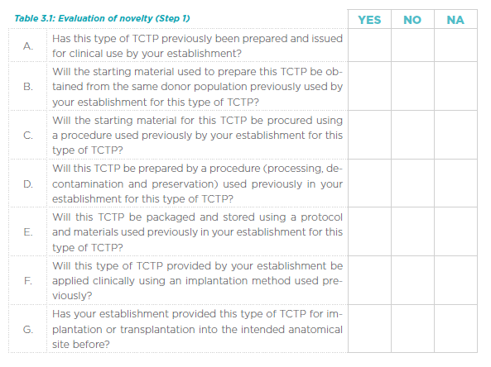
Table 8: EUROGTPII Evaluation of Novelty
If it is established that a TCTP has significant novelty, then a systematic risk assessment must be undertaken to identify and quantify the risks associated with it. This must be a comprehensive process that considers all aspects of TCTP supply chain: from donor selection through to implantation or clinical application of the product or therapy. This is the second step of the novelty and risk evaluation process
Novelty - Multi-Country Workshop
It was discussed at the multi-country workshops that a common definition of novelty should be agreed amongst CAs.
A proposed definition based on the novelty definition proposed by EUROGTPII, was drafted by WP5 and presented to Work Package Leaders in May 2020. The proposed defined is as follows and is subject to agreement: ‘any change that could significantly affect the quality and/or the safety of the blood, tissues and cells and/or the safety of recipients. This change includes a new procedure designed by the BTC establishment, a new procedure adopted from another centre that has shown scientific evidence or the application of the BTC to treat a new clinical indication’. This definition will be circulated for comment to the GAPP collaborating partners for comment.

Part B - Application Process

Application Process – WP5 Survey
The survey was used to obtain some general information on the application process in existence in CAs.
The survey indicated that majority of CAs, 80%, (16/20) who responded to the survey, have guidance for blood and tissue establishments relating to the process of applying for authorisation. In addition, it was indicated that 75% (15/20) of CAs have the requirements relating to applications for authorisation defined in legislation, 20% (4/20) in national guidance, 5% (1/20), in internal organisational policy and 15% (3/20), were undefined.
The survey was also used to determine the extent of information that was generally required to be provided in support of an application and the level of related guidance, which may be in place at Member State level.
CAs were asked what information is required to be submitted in support of an application for authorisation. 20 respondents indicated the following answers:
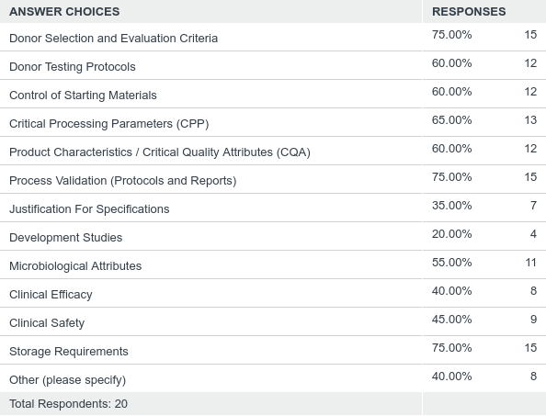
Table 9: Survey responses in relation to what information is required to be submitted in support of an application for authorisation

Application Process - Desk-Based Review:
From the associated review of other frameworks – the following process was considered the most relevant and the most applicable to blood, tissues and cells PPA:
The ‘Common Technical Document for the Registration of Pharmaceuticals for Human Use’ (CTD). This document was designed to provide a common format between Europe, USA, and Japan for the technical documentation included in an application for the registration of a human pharmaceutical product. ^{29, 30, 35, 36}

The CTD dossier is divided into five main modules:
Module1 – Administrative information and prescribing information;
Module 2 – Overviews and summaries of Modules 3–5;
Module 3 – Quality (pharmaceutical documentation);
Module 4: Non-clinical reports (pharmacology/toxicology);
Module 5: Clinical study reports (clinical trials).
Detailed guidelines are provided describing the content of each module and the majority of submissions must now follow the CTD format for submission dossiers.
The CTD drives an unambiguous and transparent application process with defined requirements for the:
- Format and content of dossiers
- The associated technical and science requirements

This approach therefore drives standardised assessment and review practices also.
E.g. for pharmaceuticals,
- Efficacy - 15 topic headings/19 guidelines
- Safety - 9 topic headings/14 guidelines
- Quality - 10 topic headings/33 guidelines

The CTD format has many clear benefits:
- Follows development scheme (process lifecycle)
- Provides a logical order for the presentation of information
- Imposes a logic to the review process by shaping both the conduct of the review and the presentation of the results of the review
- Facilitates easier analysis across applications
- Facilitates easier exchange of information
- Facilitates electronic submissions.

Two useful documents which help to further align the CTD format more towards the Tissues and Cells field were:
“The Guideline on Human Cell-Based Medicinal Products’ - is a very relevant document, with relevance to tissues and cells and generally adopting the CTD format.¹⁰
and
‘Guideline on the requirements for quality documentation concerning biological investigational medicinal products in clinical trials’,¹¹

Application process –ANSM³
For authorisation of blood components included in Category D, the request is accompanied by an argument justifying the minor nature of the change, compared to the data relating to the blood component and the existing (unmodified) medical device associated with it.

The application file for the evaluation of a labile blood product consists of two parts:
- an administrative file;
- a technical file that documents the labile blood product being evaluated.

Administrative file
This file consists of a dated and signed letter that contains the following information:
- Name and address of the applicant, or for medical devices, their manufacturer or their authorised representative, if applicable;
- Name and address of the partner (s) involved in the creation of the file;
- Name and contact information of the person responsible for the file submission;
- Name of the labile blood product to which the application for evaluation and associated medical device(s) relate;
- Purpose of the application specifying the category claimed for the file;
- If applicable, mention of the registration of the product on the list mentioned in 1° of Article L. 1221-8 of the Public Health Code or a statement that the product has already been evaluated by ANSM (recall the file reference issued by ANSM).

II. Technical file
The technical file contains all the information needed to evaluate the PSL concerned: data on its quality and, if necessary, non-clinical and clinical data.
The file consists of 4 parts:
- Part I: Summary of the file
- Part II: Data on the quality of the labile blood product
- Part III: Non-clinical data
- Part VI: Clinical Data

Application process and Multi-Country Workshop
The need for a common application template was discussed, with the example of the CTD application presented to the attendees. The benefits of the CTD format were discussed and adapting this format for BTCs was considered to be the most suitable option, with some CA’s already following this approach (ANSM; PEI). No aspects in the application process were identified as being inadequately covered by the potential CTD model. Consideration has been given to whether this would allow for accommodation of the outputs of WPs 6, 7, and 8, and it is believed that with the proposed format these outputs could potentially be included as technical annexes.

Changes to existing processes (variations)

Variations - WP5 Survey

The survey was used to determine if any CAs had existing processes in place in relation to the management of changes to existing authorisations. The majority of CAs who responded indicated that a system was in place. 88% of respondents (21/24), indicated that they had a system in place to manage changes to existing authorisations. 75% of respondents (18/24), indicated that the changes required to amend the authorisation were defined in legislation, with the same 75% (18/24) indicating that the process for managing authorisation changes was linked to the inspection system.

Specific examples of “significant changes” or changes required to amend an authorisation were provided from the survey:
- Change in Company / Establishment Name
- Changes in Rooms / facilities / premises / address;
- Change in Equipment (if new technologies);
- New products;
- New activities; (Also ceasing / voluntarily suspending activities);
- Change to existing activities (new technique / process within an activity)
- New processes;
- Change in existing processes (new technique within a process);
- Changes to procurement / collection procedures;
- Change in Responsible Person (RP);
- Changes to third party agreements;
- Changes to authorisation special conditions;
- Changes in SOP;
- Changes in Organisational Structure;
- New IT system;
Although the majority of respondents indicated a system was in place for the management of changes, the above examples highlights the need for a clear grading methodology, which harmonises the approach in relation to significant changes.

Variations - Desk-Based Review
With respect to identification of a well-defined regulatory framework for the management of changes, the desk-based review identified the following as the system with which parallels could be drawn and a system developed based on existing guidance in relation to blood, tissues and cells:
‘Guidelines on the details of the various categories of variations, on the operation of the procedures laid down in Chapters II, IIa, III and IV of Commission Regulation (EC) No 1234/2008 of 24 November 2008 concerning the examination of variations to the terms of marketing authorisations for medicinal products for human use and veterinary medicinal products and on the documentation to be submitted pursuant to those procedures’ and ‘Communication from the Commission – Guideline on the details of the various categories of variations to the terms of marketing authorisations for medicinal products for human use and veterinary medicinal products’⁸
The variations system essentially categories types of changes to a manufacturing process and defines associated reporting and/or approval requirements.
The Variations Regulation and the Annex to these guidelines set out a list of changes to be considered as minor variations of Type IA. Such minor variations do not require any prior approval, but must be notified by the holder within 12 months following implementation (‘Do and Tell’ procedure). However, certain minor variations of Type IA require immediate notification after implementation, in order to ensure the continuous supervision of the medicinal product.
The Annex to these guidelines clarifies the conditions which must be met in order for a change to follow a Type IA notification procedure, and specifies which minor variations of Type IA must be notified immediately following implementation.
For Type 1B - Within 30 days following the acknowledgement of receipt of a valid notification, the Agency will notify the holder of the outcome of the procedure. If the Agency has not sent the holder its opinion on the notification within 30 days following the acknowledgement of receipt of a valid notification, the notification will be deemed acceptable.
The Variations Regulation and the Annex to these guidelines set out a list of changes to be considered as major variations of Type II. Such major variations require approval of the relevant competent authority before implementation.

Variations – Outputs from Previous European Projects

From EUROGTP II, it has already been seen that four categories of risk can be identified by using the risk assessment tool: Negligible, Low, Moderate, and High and the tool can be used in relation to the determination of the impact of a change in the process.

Therefore, the risk categorisation from EUROGTP II could then be linked to graded notification and approval requirements. This is a proposal for the guideline.

Variations - Multi-Country Workshop
Discussion was had around the management of changes and what changes are defined as a “significant change”. This discussion was based on the survey findings and the desk based review.
It is intended that as part of the PPA guidelines, it is foreseen to provide a definition of what would be considered a significant change and to outline the resulting actions for the BE/TE and for MS CA’s in this regard. WP5 has drafted a proposed definition, ‘any change of the tissue and cell product with a risk category of orange and red according to EUROGTPII tool risk assessment or any blood product included in category A or B according to ANSM classification.’ This will be circulated to the GAPP members for comment and will be modified as necessary if EUROGTPII is adapted to incorporate blood.
Opinions were sought on risk based grading of changes and linking to regulatory / authorisation requirements. It was initially proposed that the EUROGTPII based risk categorisation is used for tissues and cells, with the variation categories for blood clearly aligned to the definitions associated with the risk categories of A, B, C and D of the ANSM guidance, however if EUROGTPII can be adapted for blood this would be considered as the option of choice.

Part D

Review and Evaluation

Review and Evaluation – WP5 Survey
The survey aimed to determine if there were a specific set of documents, which provide guidance to CAs or other relevant bodies in relation to the review / evaluation of data to be submitted to support an application for product authorisation. Only 3 CAs actually responded indicating that guidance was in place (3/19).
From the survey, as above, we’ve seen that only 3 CAs indicated that they have guidance on the identification and evaluation of ‘checkpoints’ for authorisation, with one of the CAs indicating that they also had a defined algorithm for the evaluation of data submitted in support of an application for authorisation.
Review and Evaluation – Desk-Based Review
A proposed ‘algorithm’ from WP5B in discussed below. Based on our desk-based review we are not aware of any such algorithms in place in other fields.
In relation to the review of medical devices by a notified body, it is indicated that the notified body shall, having verified the quality of clinical data supporting the clinical evaluation report of the manufacturer), prepare a clinical evaluation assessment report which sets out its conclusions concerning the clinical evidence provided by the manufacturer, in particular concerning the benefit-risk determination, the consistency of that evidence with the intended purpose, including the medical indication or indications and the post market clinical follow up (PMCF) plan.
ANSM
The technical evaluation of the files submitted for authorisation of new blood products or modifications of existing ones is based on internal evaluation and external evaluation. External evaluation relies on expert members of the Group of Experts for the Evaluation of Liable Blood Products (GTE-PSL) or appointed rapporteurs with this group. Whether they are members or rapporteurs appointed to the group, the experts are subject to a public declaration of interest.
The assessment of blood products files may also require referral to other ANSM expert groups, particularly in the areas of viral safety or toxicology.
As a result, the processing time of a request for evaluation by the ANSM covers:
- the period of assessment of the admissibility of the file;
- the technical evaluation period of the file;
- the possible period of request for additional information in view of the initial technical assessment;
- the period of appointment of the external rapporteurs;
- the period of programming of the file in the group or groups of experts;
- the drafting period of the expert panel's statement of opinion;
- the period of final approval of the statement of opinion by the experts.

JPAC⁴
JPAC has a procedure to review and evaluate new blood components, production process or blood pack. The aim of the evaluation is:
- gain sufficient data to validate the component and production method
- gain sufficient data to support the clinical use of the component
- allow the Standing Advisory Committee on Blood Components (SACBC) to recommend to the Joint UKBTS/HPA Professional Advisory Committee (JPAC) that the component should be included in the Red Book
- provide sufficient information to prevent all Blood Transfusion Centres (other than those performing a full evaluation) from having to complete a full validation of the novel
component before it enters routine production. They will only need to undertake installation
and process qualification.

For that, JPAC propose the following steps:
- Investigators identify requirement for a novel blood component.
- Investigators may obtain initial advice from the Standing Advisory Committee on Blood Components Chair (SACBC) as to whether the component should be treated as novel.
- Characterise the new blood component:
  - Apply to the Standing Advisory Committee on Information Technology (SACIT) Chair for a development barcode.
  - Investigators define the intended specification for the blood component.
  - Write the protocol for component evaluation.
  - Investigators should ensure their protocol complies with the procedure of evaluation of novel blood components, production processes and blood packs, and may seek advice from the SACBC.
  - Obtain ethics committee approval, if required.
  - Investigators apply protocol.
- Obtain Standing Advisory Committee on Blood Components (SACBC) listing of the component
  - Investigators submit report and supporting data to the SACBC for consideration.
  - The SACBC decides whether the component may be recommended for inclusion in the Red Book guidelines.
- Joint Professional Advisory Committee
  - Consider the recommendation that a new component should be listed.
- Standing Advisory Committee on Blood Components (SACBC)
  - Communicates the JPAC decision to appropriate parties.
- Standing Advisory Committee on Information Technology (SACIT)
  - Provides codes for the new blood component
  - Provides a component label and updates the UKBTS Component Portfolio.
- Blood Establishment
  - Begin production of the new blood component.
  - Produce the blood component routinely.

Review and Evaluation – Outputs from Other European Projects
VISTART WP5B
According to VISTART WP5B, high quality, safety, and efficacy/ effectiveness of BTC products have to be ensured by CA by comprehensive data-driven assessment of BTC preparation process and/or BTC product authorisation requests, and by risk-based decision-making on approval of BTC preparation process and/or BTC product authorisation.
Thus, risk-based-decision making of CA has to be strictly data based. In case of the need to balance regulatory requirements with the requirement of timely access of patients to novel therapies, a precautionary regulatory approach might be – in the case that the expected benefit justifies the expected risk – to approve conditionally under the demand of generating further data sets that are required for further assessment and final decision-making (full approval or rejection). See table 10 below for VISTART WP5B algorithm for risk based decision making.
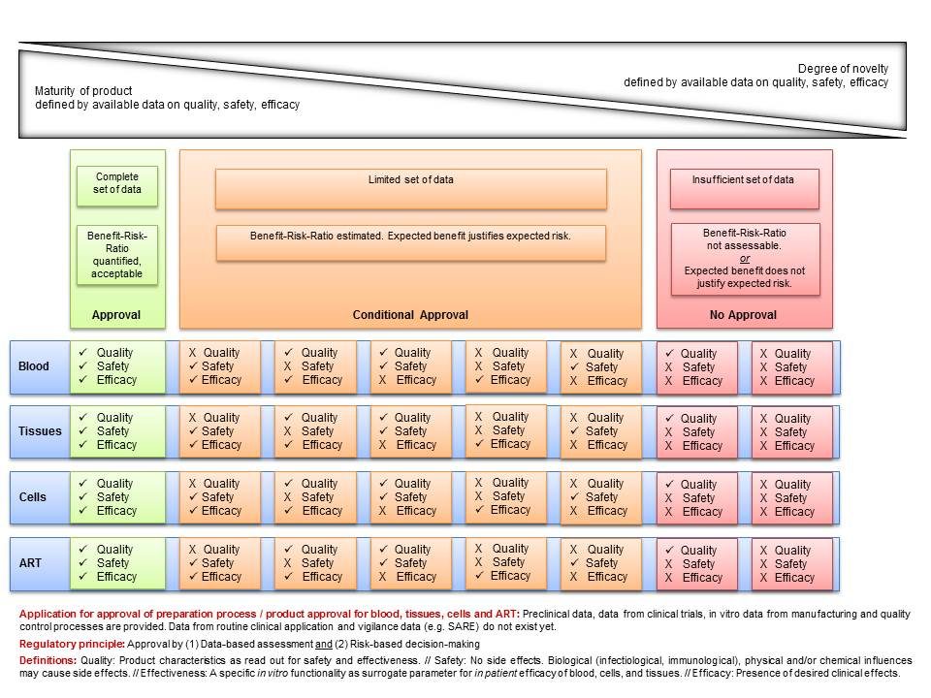
Table 10: VISTART WP5B algorithm a CA may use to decide on the authorisation of the novel PP/product in consideration of the benefit-risk-ratio as a result of assessment of quality, safety and efficacy, based on available data, reflecting the maturity of the product and its degree of novelty, respectively.
Annex 4 of WB5B also provide a Checklist to evaluate a clinical follow-up plan; however, there are no further detailed guidelines given in regard to the overall review /assessment process. As previously indicated in relation to the CTD format, this drives a high standard of assessment conformity.
This is driven by the provision of associated assessment report templates, which include a narrative that directs the discussion of the review of the submitted data under the various subsections of the CTD:
E.g., the set points and ranges should be justified by process development. Alternatively, the set points used during process validation could be accepted without further justification. Are significant process parameters missing from the description? Has the applicant justified the proposed ranges? “Ranges” only defined by an upper or a lower limit should also be considered.

Review and Evaluation – Multi-Country Workshop

The main objective of this part was to get an overview of the processes and procedures in place for the approval or refusal of authorisations. It was clear from the survey that processes were not routinely in existence within CAs. It was also to promote discussion on what level of review and evaluation should be performed over the data submitted and how this would be linked to the risk categorisation and how guidance should be provided for the CAs in assessing the application. There was discussion as to whether WP10 could provide training in relation to how CAs should assess applications; this was to be proposed as a possible training subject.
Following the discussion from the multi-country workshop and review of other countries authorisation systems, WP5 proposed table 11 to the Work Package Leaders at a meeting in May 2020. The table indicates the actions to be taken by the CA when considering an application. The table is subject to agreement.
ANSM (blood) | EUROGTPII (tissues and cells) | By the BTCB | By the CA
Category A: not on the list | Red: Controlled study/Follow up programs | Application request  Dossier  Initial questionnaire  Risk assessment  Proposal follow up  Clinical investigational plan  Comparison to standard therapy  Consider external advisory | Consider site inspection after the desk-base review  Consider external advisory  Three authorisation steps:  -Clinical investigational plan,  -Conditional/temporary authorisation  -Full authorisation that includes a follow up  If it’s a new BTC, non-authorised in any European BTCB, an European authorisation should be needed
Category B: registered; major modification | Orange: Structured plan for active collection of a specific set of data | Application request  Dossier  Initial questionnaire  Risk assessment  Proposal follow up  Clinical investigational plan  Consider external advisory | Consider site inspection  Consider external advisory  Three authorisation steps:  -Clinical investigational plan,  -Conditional/temporary authorisation  -Full authorisation that includes a follow up
Category C: registered; non-major modification | Yellow: Routine follow up programs | Application request  Dossier*  Initial questionnaire  Risk assessment  Proposal follow up | Approval of the follow up plan
Category D: registered; minor-modification | Green: SARE Report | Application request  Dossier*  Initial questionnaire  Risk assessment | If the CA agrees with the risk assessment, no further actions are needed
Table 11: Actions to be taken when application submitted

Authorisation

Authorisation – WP5
A question on the survey was used to determine the scope of the authorisations in Member States. A number of options were provided and these are detailed below:
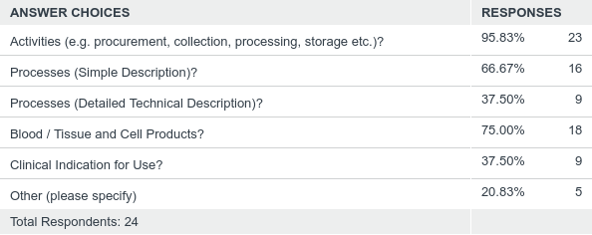
Table 12: Survey response – scope of authorisations
As indicated above, 96% (23/24) indicated that activities were included in the scope of their authorisations, with 75% (18/24) indicating that the type of blood / tissue and cell product is included in the scope. Only 37.50% (9/24) indicated that the scope included detailed technical descriptions of the process, with 37.50% (9/24) indicating that they include clinical indication for use.
The survey also indicated that 58% (11/19) of CAs that include blood / tissue and cell type on their authorisation, align their products, where applicable, with the EDQM monographs for blood and blood components and the European Tissues and Cells Compendium.
The survey indicated that 92% (22/24) defined the scope of their blood / tissue establishment within legislation, and 8% (2/24) in national guidance.
50% (12/24) grant full authorisations, 67% (16/24) grant temporary authorisations, 42% (10/24) grant conditional authorisations, and 13% (3/24) granted other authorisations, which were described as follows:
- ‘Exemption licence (for importing tissues / cells from EU / ETA countries, not fulfilling as safety and quality requirements
- 3 other authorisation regimes defined in law 1) Authorisations for MAR TEs to perform new MAR activities - given for 7 years - withdrawal if initial conditions have changed (e.g. departure of one practitioner, in case of evident fraud attempts); 2) Authorisations of new MAR biological 3) Authorisations of new techniques are listed and updated in a document. Authorised if they improve efficiency, reproducibility and security of a biological process, no expiration date for the authorisation, can be applied by all centres if they wish so authorisation is withdrawn if the annual monitoring summarised in the annual report is assessed as dangerous or inefficient
- Authorisation is normally without expiration, but we have Compliance Certificates (like GMP certificates) which are only valid for 2 years’
It was indicated that the types of authorisations were defined in legislation in 79% (19/24) of CAs, and in national guidance in 8% (2/24) of CAs and in internal organisational policies in 8% (2/24) of CAs and it was not defined in 8% (2/24) of CAs.

Authorisation – Desk-Base Review
ANSM
After the group of experts has given the final approval of the new blood product or the modification of an existing one, it is notified to the applicant.
JPAC
It the new product is accepted, the investigators are informed and the Standing Advisory Committee on Information Technology (SACIT) is requested to proceed with the provision of appropriate labels.
They inform all the UK Blood Transfusion Services, and they provide copies of the data and report used to accept the new blood component. If the request is rejected a report with all the supporting reasons is submitted.

Authorisation – Output from Previous European Projects
WP5 B PRINCIPLE #3
If the expected benefit outbalances the expected risk, a conditional authorisation for the PP/product may be released. Conditional authorisation may be based on an adequate clinical follow up (CFUp) study plan, approved by the Competent Authority
WP5B indicates that, taken together, if there is sufficient indication that a BTC prepared with novel PP or a novel BTC product can have a high therapeutic value (table 10), and that, therefore, it is in the public interest to have the BTC product introduced into therapy, even though further important details are still required to facilitate a comprehensive assessment of the BTC product, a specific mechanism has to be defined that allows for balancing regulatory requirements with the need of timely access of patients to novel BTC therapies.
- Under the above mentioned circumstances, the BTC-CA may consider issuing a conditional authorisation of PP/product.
- Such conditional approval will have to require that the data lacking to assure a comprehensive assessment of the BTC-PP/product at the time of submission is systematically generated and reported to the BTC-CA.
- The BTC-CA shall review these data on a regular basis.
- However, the decision of the CA to release a full approval, conditional approval or rejection of the application for a BTC prepared with novel PP/product has also to take into account the benefit of the product for clinical application to patients.

Conditional Authorisation

As indicated above, the survey results showed that 42% (10/24) of CAs issued conditional authorisations. 67% (16/24) of respondents issued temporary authorisations.
Conditional Authorisation – Desk-Based Review
The European Medicines Agency (EMA) supports the development of medicines that address unmet medical needs of patients. In the interest of public health, applicants may be granted a conditional marketing authorisation for such medicines where the benefit of immediate availability outweighs the risk of less comprehensive data than normally required, based on the scope and criteria defined in legislation and guidelines⁵.
Medicines for human use are eligible if they are aimed at treating, preventing or diagnosing seriously debilitating or life-threatening diseases. This includes orphan medicines.
For products intended for use in emergency situations, less comprehensive pharmaceutical and non-clinical data may also be accepted.
Conditional marketing authorisations may be granted if the committee for medicinal products for human use (CHMP) finds that all the following requirements are met:
- the benefit-risk balance of the product is positive;
- it is likely that the applicant will be able to provide comprehensive data;
- unmet medical needs will be fulfilled;
The benefit to public health of the medicinal product's immediate availability on the market outweighs the risks due to need for further data.
The EMA has published a 10 year report on its experience with conditional marketing authorisations, with data collected between July 2006 and June 2016. Of the 30 medicines which received conditional marketing authorisations during this period, none had to be revoked or suspended⁶.

Authorisation - Multi-Country Workshop

The discussion surrounding authorisation, raised a number of discussion points, which need to be considered when developing the guidelines. Should authorisations be linked to clinical indication for use? Should options in relation to restrictions on an authorisation consider the following: time limitation; limited number of patients; limited cohort of patients; be restricted to use in specific centres? These issues will be further discussed and addressed during the development of the guidelines.

Part E - Framework of Competent Authority

Framework of CA – WP5 Survey
The survey was utilised to get an overview on what is required at a CA to implement a PPA system and discuss the various models at CAs. This includes gaining information on
- Organisational models and mandates of CA’s;
- Optimal composition of assessment team;

Of the 19 respondents, 58% (11/19) indicated that, yes, there were minimum requirements for qualification defined for those CA personnel involved in the review / evaluation of applications for authorisation.
In the majority of cases that answered yes, inspectors were responsible for the review and evaluation of applications for authorisation. It was determined that one CA employ the use of a “supervisory board” of 5 people.
Of 20 respondents, 30% (6/20) indicated that the CA used external (third party) experts or expert panels in the review / evaluation of applications for authorisation. With the majority indicating that external experts or panels were not used.

Framework of CA – Desk-Based Review

Medical Devices Conformity Assessment:
Medical device Regulation 2017/745 details the requirements for experts employed by the notified body and also external experts / expert panels:
3.2.4. The notified body shall have permanent availability of personnel with relevant clinical expertise and where possible such personnel shall be employed by the notified body itself. Such personnel shall be integrated throughout the notified body's assessment and decision-making process in order to:
- identify when specialist input is required for the assessment of the clinical evaluation conducted by the manufacturer and identify appropriately qualified experts;
- be able to review and scientifically challenge the clinical data contained within the clinical evaluation, and any associated clinical investigations, and appropriately guide external clinical experts in the assessment of the clinical evaluation presented by the manufacturer;
- be able to scientifically evaluate and, if necessary, challenge the clinical evaluation presented, and the results of the external clinical experts' assessment of the manufacturer's clinical evaluation;
- be able to ascertain the comparability and consistency of the assessments of clinical evaluations conducted by clinical experts;
- be able to make an assessment of the manufacturer's clinical evaluation and a clinical judgement of the opinion provided by any external expert and make a recommendation to the notified body's decision maker; and
- be able to draw up records and reports demonstrating that the relevant conformity assessment activities have been appropriately carried out.
3.2.5. The personnel responsible for carrying out product-related reviews (product reviewers), such as technical documentation reviews or type examination, including aspects such as clinical evaluation, biological safety, sterilisation and software validation, shall have all of the following proven qualifications:
- successful completion of a university or a technical college degree or equivalent qualification in relevant studies, e.g. medicine, pharmacy, engineering or other relevant sciences;
- four years' professional experience in the field of healthcare products or related activities, such as in manufacturing, auditing or research, of which two years shall be in the design, manufacture, testing or use of the device or technology to be assessed or related to the scientific aspects to be assessed;
- knowledge of device legislation, including the general safety and performance requirements set out in Annex I;
- appropriate knowledge and experience of relevant harmonised standards, common specifications (CS) and guidance documents;
- appropriate knowledge and experience of risk management and related device standards and guidance documents;
- appropriate knowledge and experience of clinical evaluation;
- appropriate knowledge of the devices which they are assessing;
- appropriate knowledge and experience of the conformity assessment procedures laid down in Annexes IX to XI, in particular of the aspects of those procedures for which they are responsible, and adequate authorisation for carrying out those assessments;
- the ability to draw up records and reports demonstrating that the relevant conformity assessment activities have been appropriately carried out.
- the ability to draw up records and reports demonstrating that the relevant conformity assessment activities have been appropriately carried out.
3.3. Documentation of qualification, training and authorisation of personnel
3.3.1. The notified body shall have a procedure in place to fully document the qualification of each member of personnel involved in conformity assessment activities and the satisfaction of the qualification criteria referred to in Section 3.2.
3.5. Monitoring of competences, training and exchange of experience
3.5.1. The notified body shall establish procedures for the initial evaluation and on-going monitoring of the competence, conformity assessment activities and performance of all internal and external personnel, and subcontractors, involved in conformity assessment activities.
3.5.2. Notified bodies shall review at regular intervals, the competence of their personnel, identify training needs and draw up a training plan to maintain the required level of qualification and knowledge of individual personnel. That review shall at a minimum, verify that personnel:
- take part in the internal exchange of experience and the continuous training and education programme referred to in Section 3.1.2.
Article 106
- Expert panels and expert laboratories may be designated in areas where the Commission, in consultation with the medical device co-ordination group (MDCG), has identified a need for the provision of consistent scientific, technical and/or clinical advice or laboratory expertise in relation to the implementation of this Regulation. Expert panels and expert laboratories may be appointed on a standing or temporary basis.

- Expert panels shall consist of advisors appointed by the Commission on the basis of up-to-date clinical, scientific or technical expertise in the field and with a geographical distribution that reflects the diversity of scientific and clinical approaches in the Union.

10. Expert panels and expert laboratories may have the following tasks, depending on the requisite
needs:
to contribute to the development and maintenance of appropriate guidance and CS for:
clinical investigations,
clinical evaluation and PMCF,
performance studies,
performance evaluation and post-market performance follow-up,
physico-chemical characterisation, and microbiological, biocompatibility, mechanical, electrical, electronic or non-clinical toxicological testing’
Table 13: Medical device Regulation 2017/745
Biologics Working Group (BWP)
The BWP provides on request of the CHMP a forum for discussion and harmonisation amongst quality and other experts to maintain and reinforce a uniform approach to the understanding of biotechnology and biological issues and to avoid/eliminate divergences in assessing biotechnology problems and interpreting biotechnology guidelines. The forum of the BWP should facilitate the efficient use of European expertise in the development and maintenance of the scientific review of applications for marketing authorisations for biotechnology or biological derived medicinal products including those from emerging technologies and therapies.

The BWP is therefore established to provide recommendations to the Committee(s) on all matters relating directly or indirectly to quality aspects and safety in relation to quality of biological and biotechnological medicinal products and to perform the tasks as per the following mandate.

Mandate:
- The BWP, based on the evaluation and conclusions from the rapporteur and co-rapporteur, will support the CHMP to maintain consistent evaluation of the pharmaceutical dossier of biotechnological and biological medicinal products. The BWP contribution to dossier evaluation should facilitate consistency in assessments, and thereby in the coherence of the CHMP opinion.

- At the request of the CHMP, provision of scientific advice on general and product-specific matters related to quality aspects of biological and biotechnological medicinal products. The BWP shall provide reports to scientific advice working party (SAWP).

- Preparation, review and update of guidelines in conjunction with other appropriate working parties.
- Liaison with interested parties (pharmaceutical industry associations such as EFPIA-EBE, Vaccines Europe, Medicines for Europe, Europa-Bio, AESGP, PPTA etc., learned society, public health-care professional organisations, patient organisations, etc. See point 6.9.).
- International cooperation on quality aspects and safety aspects related to quality of biological and biotechnological medicinal products related matters, in conjunction with other relevant working parties.
- Provide CHMP with a contribution to ICH on quality and safety aspects related to the quality of biological and biotechnological medicinal products.
- Contribution to CHMP scientific opinions in the context of collaboration with WHO for the evaluation of medicinal products intended exclusively for markets outside the community for quality and safety aspects related to the quality of biological and biotechnological medicinal products.
- Setting up of drafting groups
- Liaison with other working parties and ad-hoc GMP inspection services meetings on quality and safety aspects related to the quality of biological and biotechnological medicinal products.
- Advise as appropriate on other applications of biological/biotechnological methods in relation to medicinal products and their use.
- Advice, through the CHMP, to the European Commission on quality aspects of biological and biotechnological medicinal product-related matters in relation to medicinal products.
- On request, advice, through the CHMP, to other Committees and working parties/working groups on quality aspects of biological and biotechnological medical product related matters in relation to medicinal products
- Focus and catalyst for training for quality aspects and safety aspects related to quality of biological and biotechnological medicinal products
- Interaction with the European Directorate of the Quality of Medicines (EDQM) particularly in relation to European Pharmacopoeia activities, biological standardisation and the Official Medicines Control Laboratory network activities.
- constitute a rapid-acting crisis group to take on board specific issues related to the quality and safety aspects of biological/biotechnological medicinal products with the objective of exchanging information on a European level and to co-ordinate responses to the public in a timely manner
JPAC has a number of advisory committees, including, the Standing Advisory Committee on Blood Components (SACBC), this committee:
- Set specifications for blood components, evidence-based where possible
- Develop and review validation of novel blood components
- Assess acceptability for use of novel blood components
- Assess and set requirements for storage and transport systems for blood components
- Co-ordinate with the Standing Advisory Committee on Information Technology regarding labelling and unique identification of blood components and maintenance of the product portfolio (website)
- Develop generic protocols for evaluating methods for the collection and processing of blood and blood components
- Contribute content to the JPAC website (background papers and references etc.)
- Co-ordinate with other SACs and, other relevant UK Working Groups, as appropriate

Framework of CA – Output from Previous European Projects
The Vistart project doesn’t specify training requirements in relation to ‘assessment’ but does define general training requirements for inspectors.
A formal academic qualification in medical, biological or life science discipline is required.
Selection criteria – practical post graduate experience in relevant areas of operation within blood or tissue establishments / appropriate alternative professional experience e.g. experience in relevant industry, healthcare institution or other regulatory body.
Inspectors should undertake appropriate training to ensure competence in the skills required for preparing, conducting, reporting, and following up inspections. A programme of ongoing training should be in place to maintain and develop inspection skills
Inspection methodology training
- Training on how to prepare for an inspection
- Training on how to conduct an inspection
- Training on post inspection activities

Framework for CA – Multi-Country Workshop
Discussion from the workshop raised a number of discussion points: does the inspector / assessor require a certain level of experience, training or qualification to be involved with applications for authorisation? Do any CA’s employ assessors / internal experts (independent of inspectors) to review and evaluate applications for authorisation? How are the external panels selected? What are the criteria and level of expertise required? What controls are in place to ensure independence and impartiality? Confidentiality etc.? Opinion on the establishment of a European level panel? As the assessment of PPAs is not routinely performed in CAs these questions need to be considered when drafting the guidelines. The use of external experts will be up to each CA, but confidentiality and impartiality must be considered. The use of advisory boards / external experts will be referenced within the guidance document. The availability of a European level panel would be welcomed but the sharing of sensitive information may not be appropriate. The database as an output of WP9 may allow for some information sharing, but this is still unclear.

IV. Discussion and conclusions

The aim of WP 5 is the development of general good practice guidelines for PPA – putting a system and standard operating procedures in place at the Member State level, including a methodology to inform blood and tissue establishments (BE/TE) regarding those procedures.

The guidelines shall include:

- An overview of the steps from the request submitted by a BE/TE to the release of authorisation by CA;
- Timing of application for PPA;
- Definition of novelty and significant change in preparation process;
- Terms for application (also building on the outcomes of VISTART WP6 - manual for inspections);
- Optimal composition of the assessing team in the CA (members' qualifications, background, use of external experts etc.), definition of inspectors’ involvement;
- Definition of types of authorisation (e.g. full, conditional, temporary – taking into account the outcomes of VISTART WP5 part B);
- Development of model template forms for PPA;

Based on the feedback from the multi-country workshops, review of outputs from previous European projects, GAPP partner review of this report, and further ongoing liaison with the other GAPP work packages, we will finalise a draft outline structure for the PPA Guidelines incorporating the finalised outputs from the technical work packages with regards to:
- Authorisation of changes to activities performed by blood and tissue establishments (Work Package 6); and their definition of Critical Process Parameters and Critical Quality Attributes – Extent of Validation;
- Assessing the quality and safety of donor testing, microbial inactivation and sterilisation steps as part of PPA (Work Package 7);
- Assessing Clinical data as part of PPA (Work Package 8);

As indicated within the report, the proposed framework of the guideline can be seen in table 14. This proposal has been discussed with a number of the other working groups and has been accepted as an appropriate framework.
Part A
Risk Assessment
- Definition of novelty
- Significant changes
Part B
Application Process
- New application
Modules 1 -5
(1: Administrative information; experts involved in compilation of the dossier; labelling; leaflet.
2: characterisation of the blood/ tissue/cell; quality overview; non clinical overview; clinical overview; risk benefit evaluation; clinical follow up; clinical investigation plan.
3: Composition of blood/tissue/cell; donor selection and testing; preparation process; validation and stability; quality control.
4: non-clinical study report.
5: clinical study report)
- Variations
Part C
Technical Annexes
Part D
- Review and evaluation
- Authorisation
Part E
Framework of Competent Authority
Table 14: Proposed framework for guideline
Definitions for novelty and significant change have been drafted by WP5 and will be shared with all GAPP members for comment and agreement:
Novelty: Any change that could significantly affect the quality and/or the safety of the blood, tissues and cells and/or the safety of recipients. This change includes a new procedure designed by the BTC establishment, a new procedure adopted from another centre that has shown scientific evidence or the application of the BTC to treat a new clinical indication.
Significant change: Any change of the TCP with a risk category of orange and red according EUROGTP tool risk assessment or any blood product included in category A or B according ANSM classification.
In addition, Barcelona Tissue Bank are reviewing and adapting the EUROGTPII so that it also includes blood, the use of EUROGTPII for both tissues and cells, and blood will be incorporated into the guidelines.
WP5 will continue to work with other working groups to ensure that their outputs are adequately referenced within the guideline.
The Commission Expert Sub-Group on Inspections in the Blood and Tissues and Cells Sectors (IES) is a sub-group of Competent Authorities on Substances of Human Origin (CASoHO) Expert Group. The work of the group is conducted on a voluntary basis and consists of multiple work clusters. One of these work clusters is currently reviewing VISTART WP6 – ‘Inspection guidelines for EU Competent Authorities responsible for the inspection and authorisation of blood and tissue establishments’.

WP5 would like to thank the many Competent Authorities as well as the European Commission who participated in the Multicounty Workshops and in the survey.

Appendix 1 – GAPP Work Package 5 Survey Results:

Appendix 1 GAPP Work Package 5 Survey Results:
Section 1: Framework for authorisation at Competent Authority
Q1: Name of Competent Authority
Q2: Member State
Q3: Sectors Regulated by your Competent Authority
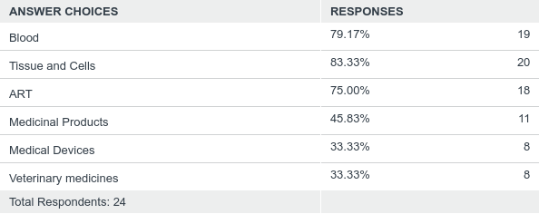
Q4: Is your Competent Authority:
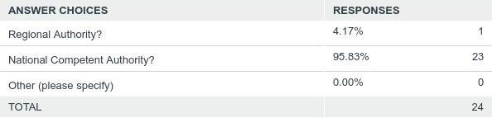
Q5: Is your Competent Authority involved in the GAPP joint action?
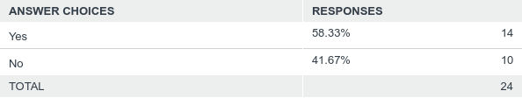

Q6: Which of the following are included in the scope of your blood or tissue establishment authorisations?
Q7: If you ticked blood / tissue and cell products above are the products listed on your authorisations, linked to, or aligned with:
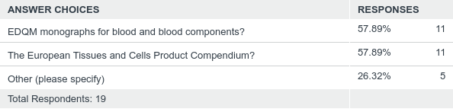
Q8: Is the scope of your blood or tissue establishment authorisations defined within:
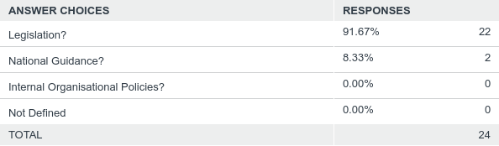

Q9: What type of authorisations do you grant?
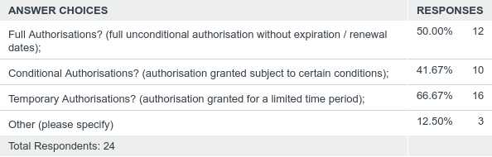
Q10: Are the types of authorisation defined within:
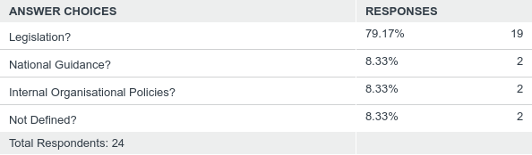
Q11: Does the Competent Authority have a system in place to manage changes to existing authorisations?
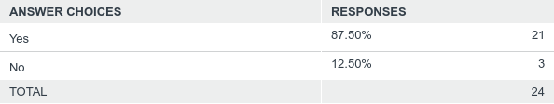
Q12: Is it defined what changes require an amendment to the authorisation?
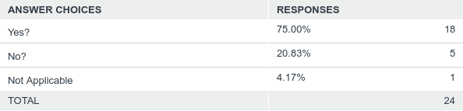

Q13: Is the process for managing changes linked to the inspection system?
Q14: Does your Competent Authority have a system in place to manage the authorisation of new/novel:
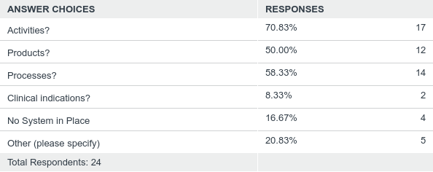
Q15: Is it defined what constitutes a new or novel activity / product / process / clinical indication?
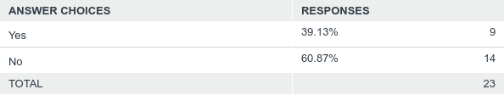
Q16: Is the process for managing applications for authorisation of new or novel activities / products / processes / clinical indications linked to the inspection system?
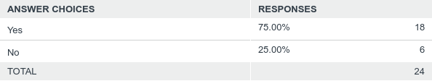

Section 2: System for preparation process authorisation
Q1: Name of Competent Authority
Q2: Does your Competent Authority have guidance for blood or tissue establishments relating to the process of applying for authorisation?
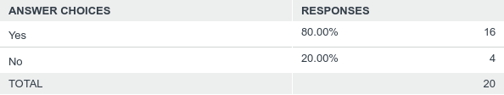
Q3: Is the application process defined for the following cases:
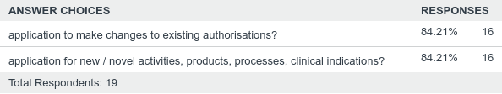
Q4: What information is required is required to be submitted in support of an application for authorisation?
Q5: Are the requirements for blood establishments / tissue establishments relating to applications for authorisation defined within
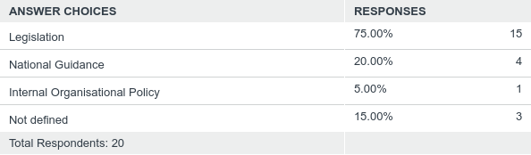
Q6: Does your Competent Authority have a system for the risk categorisation or grading of the following?
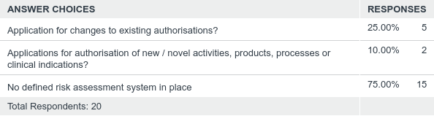
Q7: Does the outcome of the risk assessment determine specific requirements for approval of the application?
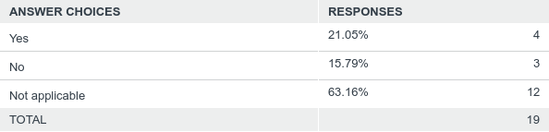
Q8: Are risk categories defined within:
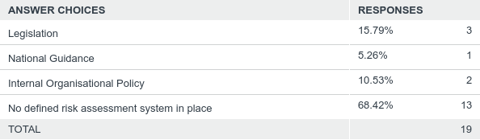

Q9: Is your Competent Authority aware of the outputs of the EuroGTPII joint action?
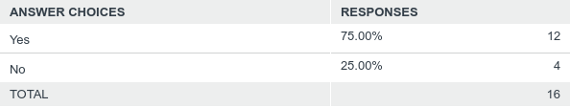
Q10: Does your Competent Authority currently intend to use the EuroGTPII tool as a basis for risk assessment in a regulatory context?
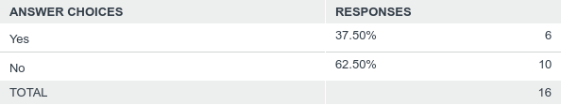
Q11: Are the risk categories defined by EuroGTPII comparable to those within your Competent Authority for risk assessment?
Q12: Where are the risk categories aligned?
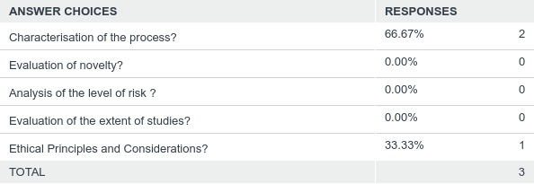

Section 3: Review and authorisation
Q1: Name of Competent Authority
Q2: In your Member State, is there a specific set of documents which provide guidance to Competent Authorities or other relevant bodies in relation to the review / evaluation of data to be submitted to support an application for product authorisation?
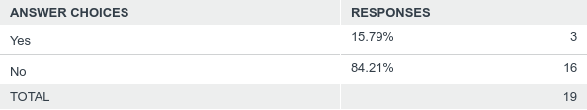
Q3: If you answered yes to the above, does the guidance include;
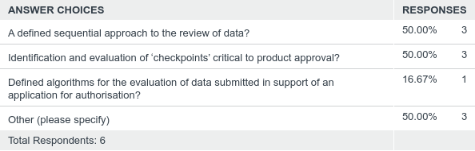
* This question was in fact only correctly answered by 3 CAs, as there was a pre-requisite to have answered yes to Q2 prior to answering Q3.
Q4: In your Member State, are the minimum requirements for qualification defined, for those Competent Authority personnel involved in the review / evaluation of applications for authorisation?
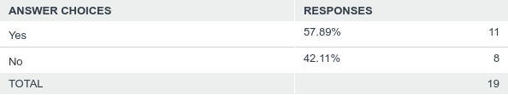
Q5: Does your Competent Authority use external (third party) experts or expert panels in the review / evaluation of applications for authorisation?
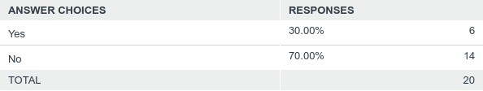
Q6: Does your process for the review of applications for authorisation involve the use of any computer based systems for the evaluation of submitted data (by using defined algorithms or in any other way)?
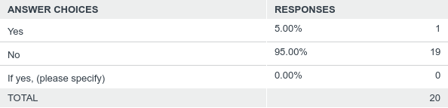
Q7: Does your authorisation framework provide for information sharing at an international level in order to support the review / evaluation of applications for authorisation?
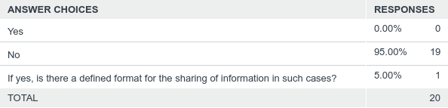
Q8: Is there a mutually accessible database of national authorisations or details of the associated review / evaluation?
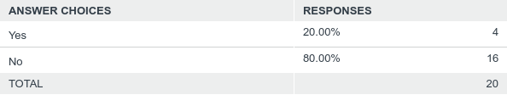
Q9: Do you have any case studies or training materials available to demonstrate the risk categorisation and the subsequent review / evaluation of application for product authorisations?
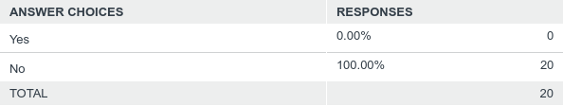

Appendix 2 - Bibliography

- VISTART Joint Action (Project Number 676969), Principles for Competent Authorities for the Evaluation and Approval of Clinical Follow Up Protocols for Blood, Tissues and Cells Prepared with Newly Developed and Validated Processing Methodologies, Work Package 5b Deliverable 5.4, 2018

- EuroGTP II Project (Project Number 709567) Good Practices for Evaluating Quality, Safety and Efficacy of Novel Tissue and Cellular Therapies and Products - Guidance, Methodologies and Tools, 2019 http://goodtissuepractices.eu/

- Agence nationale de sécurité du médicament et des produits de santé (ANSM), Notice to Applicants - Evaluation of Labile Blood Products, 2012

- Joint UKBTS Joint Professional Advisory Committee (JPAC) Guidelines for the Blood Transfusion Services in the UK, Chapter 8: Evaluation of Novel Blood Components, Production Processes and Blood Packs: Generic Protocols, 8th Edition, 2013

- Commission Regulation (EC) No 507/2006 of 29 March 2006 on the conditional marketing authorisation for medicinal products for human use falling within the scope of Regulation (EC) No 726/2004 of the European Parliament and of the Council

- EMA - Conditional Marketing Autorisations https://www.ema.europa.eu/en/human-regulatory/marketing-authorisation/conditional-marketing-authorisation

- European Medicines Agency, ICH Topic M 4 Q Common Technical Document for the Registration of Pharmaceuticals for Human Use – Quality, Step 5, Common Technical Document for the Registration of Pharmaceutical for Human Use, Quality Overall Summary of Module 2 and Module 3: Quality, Ref: (CPMP/ICH/2887/99 - Quality), July 2003

- European Medicines Agency Post-Authorisation Procedural Advice for Users of the Centralised Procedure, 29 April 2019, EMEA-H-19984/03 Rev. 82

- Guidelines on the details of the various categories of variations, on the operation of the procedures laid down in Chapters II, IIa, III and IV of Commission Regulation (EC) No 1234/2008 of 24 November 2008 concerning the examination of variations to the terms of marketing authorisations for medicinal products for human use and veterinary medicinal products and on the documentation to be submitted pursuant to those procedures, 2013/C 223/01

- Communication from the Commission – Guideline on the details of the various categories of variations to the terms of marketing authorisations for medicinal products for human use and veterinary medicinal products, 2008

- Guideline on Human Cell-Based Medicinal Products, Committee for Medicinal Product for Human Use (CHMP), EMEA/CHMP/410869/2006

- Guideline on the Requirements for Quality Documentation Concerning Biological Investigational Medicinal Products in Clinical Trials, Committee for Medicinal Product for Human Use (CHMP), EMA/CHMP/BWP/534898/2008

- Procedural advice on the evaluation of advanced therapy medicinal product in accordance with Article 8 of Regulation (EC) No 1394/2007, 25 January 2018, EMA/630043/2008

- Development of non-substantially manipulated cell-based ATMPs: flexibility introduced via the application of the risk-based approach, July 2017, EMA/CAT/216556/2017

- Committee for Advanced Therapies (CAT), Procedural Advice on the Evaluation of Advanced Therapy Medicinal Product in Accordance with Article 8 of Regulation (EC) No. 1394/2007, 31st March 2009, EMEA/630043/2008

- Guideline on the risk-based approach according to annex I, part IV of Directive 2001/83/EC applied to Advanced therapy medicinal products, 11 February 2013, EMA/CAT/CPWP/686637/2011

- EU decision-making for marketing authorization of advanced therapy medicinal products: a case study, de Wilde et al, Drug Discovery Today, Vol 23, No 7, July 2018

- An overview of the Common Technical Document (CTD) Regulatory Dossier, Debbie Jordan, The European Medical Writers Association 2014, Vol. 23, No. 2, pg. 101-105

- Good Review Practices - A Common Regulatory Language - Influenced by the CTD, Justina A. Molzon, Center for Drug Development and Research, U.S. Food and Drug Administration, Presentation at 34rd Latin American Regulatory Conference, Panama City, Panama, April 13-15, 2011

- Exploring the Regulatory Decision-Making Process for Medicines, Giovanni Tafuri, 2013, World Health Organisation

- EDQM: 50 Years of Leadership in the Quality of Medicines Paving the Way for the Future, Workshop - Finished Product Monograph, Presentation on 6-8 October 2014, Strasbourg, France

- Directive 2001/83/EC of the European Parliament and of the Council of 6 November 2001 on the Community code relating to medicinal products for human use.

- Directive 2004/24/EC of the European Parliament and of the Council of 31 March 2004 amending, as regards traditional herbal medicinal products, Directive 2001/83/EC on the Community code relating to medicinal products for human use.

- Homeopathic Medicinal Product Working Group (HMPWG) - Points to consider on non-clinical safety of homeopathic medicinal products of botanical, mineral and chemical origin.

- Homeopathic Medicinal Product Working Group (HMPWG) – Guidance on module 3 of the homeopathic medicinal products dossier.

- Homeopathic Medicinal Product Working Group (HMPWG) – Points to consider on stability testing of homeopathic medicinal products.

- Homeopathic Medicinal Product Working Group (HMPWG) - Points to consider on safety of homeopathic medical products from biological origin.

- Homeopathic Medicinal Product Working Group (HMPWG) – Points to consider on the selection of microbial limits for non-sterile homeopathic raw materials, stocks, preparations and products.

- Homeopathic Medicinal Product Working Group (HMPWG) – Guidance on Module 3.2.S for Nosodes.

- Notice to applicants: Medicinal Products for Human Use; Volume 2B: Presentation and content of the dossier; Module 1.2: Administrative Information Application Form - Homeopathic Medicinal Products for Human Use.

- Volume 2B: Notice to Applicants; Medicinal Products for Human Use; Presentation and Format of the Dossier; Common Technical Document (CTD).

- World Health Organisation: Safety Issues in the Preparation of Homeopathic Medicines.

- HPRA Guide to Registration of Homeopathic Medicinal Products, AUT-G0037-4, 12 Nov 2014.

- HPRA Guide to National Rules Scheme for Homeopathic Medicinal Products for Human Use, AUT-G0057-1, 11 May 2010.
- HPRA Guide to Traditional Herbal Medicinal Products Registration Scheme, AUT-G0029-3, 20 January 2012.

- International Conference on Harmonisation of Technical Requirements for Registration of Pharmaceuticals for Human Use, ICH Harmonised Tripartite Guideline, The Common Technical Document for the Registration of Pharmaceuticals for Human Use: Quality – M4Q(R1), Quality Overall Summary of Module 2, Module 3 : Quality, Current Step 4 version dated 12 September 2002.

- International Conference on Harmonisation of Technical Requirements for Registration of Pharmaceuticals for Human Use, ICH Harmonised Tripartite Guideline, The Common Technical Document for the Registration of Pharmaceuticals for Human Use: Safety – M4S(R2), Nonclinical Overview and Nonclinical Summaries of Module 2, Organisation of Module 4, Current Step 4 version dated 20 December 2002.

- Regulation (EU) 2017/745 of the European Parliament and of the Council of 5 April 2017 on Medical Devices

- Regulation (EU) 2017/746 of the European Parliament and of the Council of 5 April 2017 on In Vitro Diagnostic Medical Devices

- MEDDEV 2.7/1 Rev 4 Clinical Evaluation: A Guide for Manufacturers and Notified Bodies under Directives 93/42/EEC and 90/385/EEC

- MEDDEV 2.7/2 Rev 2 Guidelines for Competent Authorities for Making a Validation / Assessment of a Clinical Investigation Application under Directives 93/42/EEC and 90/385/EEC

- MEDDEV 2.7/4 Guidelines on Clinical Investigation: A Guide for Manufacturers and Notified Bodies

- Global Harmonisation Task Force GHTF/SG1/N78:2012 Principles of Conformity Assessment for Medical Devices

- International Medical Device Regulators Forum IMDRF/GRRP/WG/N47 FINAL:2018 Essential Principles for Safety and Performance of Medical Devices and IVD Medical Devices

- Global Harmonisation Task Force GHTF/SG1/N063:2011 Summary Technical Documentation (STED) for Demonstrating Conformity to the Essential Principles of Safety and Performance of In Vitro Diagnostic Medical Devices

- Global Harmonisation Task Force GHTF/SG1/N011:2008 Summary Technical Documentation for Demonstrating Conformity to the Essential Principles of Safety and Performance of Medical Devices (STED)

- Global Harmonisation Task Force GHTF/SG5/N8:2012 Clinical Evidence for IVD Medical Devices - Clinical Performance Studies for In Vitro Diagnostic Medical Devices

- Global Harmonisation Task Force GHTF/SG5/N4:2010 Post-Market Clinical Follow-Up Studies

Appendix 3 Acronyms

AESGP Association of the European Self-Care Industry
ANSM National Agency for the Safety of Medicines and Health Products
ART / MAR Assisted Reproduction Technology / Medically Assisted Reproduction
ATMP Advanced Therapy Medicinal Product
BE Blood Establishment
BTC Blood, Tissues, Cells
BTCB Blood, Tissue, Cell Bank
BWP Biologics Working Group
CASoHO Competent Authorities on Substances of Human Origin
CATSALUT Catalan Health Service
CHMP Committee for Medicinal Products for Human Use
CPP Critical Processing Parameters
CQA Critical Quality Attributes
CS Common Specifications
CTD Common Technical Document
EDQM European Directorate of the Quality of Medicines
EFPIA-EBE European Federation of Pharmaceutical Industries and Associations - European Biopharmaceutical Enterprises
EMA European Medicine Agency
EU European Union
EURO GTP European Good Tissue Practice
Europa-Bio The European Association for Bioindustries
GMP Good Manufacturing Process
GTE-PSL Group of Experts for the Evaluation of Liable Blood Products
HPRA Health Products Regulatory Authority
HSC / HPSC Haematopoietic Stem Cells / Haematopoietic Peripheral Stem Cells
ICH International Council for Harmonisation
IES Commission Expert Sub-Group on Inspections in the Blood and Tissues and Cells Sectors
ISO International Organisation for Standardisation
IT Information Technology
JPAC Joint UKBTS/HPA Professional Advisory Committee
MAA Marketing Authorisation Application
MDCG Medical Device Coordination Group
MS Member State
NCA / CA National Competent Authority
NBP / BP New Blood Product / Blood Product
OCATT Catalan Transplant Organisation
PEI Paul-Ehrlich-Institute
PMCF Post Market Clinical Follow-up
PP Preparation Process
PPA Preparation Process Authorisation
PPD Preparation Process Dossier
PPTA Plasma Proteins Therapeutic Association
RP Responsible Person
SA Standing Advisory Committees
SACBC Standing Advisory Committee on Blood Components
SACIT Standing Advisory Committee on Information Technology
SARE Serious Adverse Reaction / Event
SAWP Scientific Advice Working Party
SOP Standard Operating Procedure
TCTP Tissue and Cellular Therapy Product
TE Tissue Establishment
UKBTS United Kingdom Blood Transfusion Service
VISTART Vigilance and Inspection for the Safety of Transfusion, Assisted Reproduction and Transplantation)

WP Work Package

WHO World Health Organisation

