DELIVERABLE 5.1
  - AUGUST 2020

Facilitating the Authorisation of Preparation Process for blood, tissues and cells
  - EXTENSION OF THE OUTPUTS OF PREVIOUS PROJECTS, VISTART WP5B, EUROGTP ii, eTC… TO BE APPLICABLE TO BLOOD.
Date of submission: | XX.XX.2020
Work package: | WP5
Author(s): | HPRA AND OCATT (CATSALUT)
Dissemination level: | Draft of a public report
Contents
Introduction 2
I. VISTART 2
1. Introduction 2
2. VISTART Principles 3
3. Survey 7
4. Definitions 8
5. Risk analysis 9
6. Inspection guideline 11
II. EUROGTP II 13
1. Introduction 13
2. Novelty 14
Previous steps 14
Evaluation of novelty 15
3. Risk assessment. 16
4. Definition of studies extent. 17
Risk reduction strategies 17
Risk reduction strategies 18
5. Blood. 20
IV. EECTR 21
Data Base 22
V. Conclusions 23
Acronyms 24
References 25

Introduction
According to the Grant Agreement, WP5 shall develop guidance on how a Preparation Process Authorization (PPA) should or could be organized. WP5 is led by the Human Products Regulatory Authority (HPRA) from Ireland and the Catalan Transplant Organization (OCATT) of the Catalan Health Service (Spain).
Prior to the development of the Overall Guidance, a review of previous projects should be performed. An analysis of existing procedures and drafting of authorization principles for novel process defined by VISTART Joint Action will be done. There will also be a revision of the outcomes of EUROGTP II and ECCTR projects. These latter two, do not include blood.
This review of previous projects will help to develop the Overall Guideline, especially as the Guideline should contain:
- An overview of the single authorisation steps from the request submitted by a Blood Establishment (BE) and Tissue Establishment (TE) to the release of authorisation by Competent Authority (CA)
- Timing of application for Preparation Process Authorization (PPA)
- Definition of significant change in preparation process
- Terms for application (also building on the outcomes of VISTART WP6 - manual for inspections)
- Organisational models and mandates of the CAs responsible for the PPA
- Optimal composition of the assessing team in the CA (members' qualifications, background, use of external experts etc.), definition of inspectors’ involvement,
- Definition of types of authorisation (e.g. full, conditional, temporary – taking into account the outcomes of VISTART WP5 part B)
- Development of model template forms for PPA.

I. VISTART

Introduction

VISTART¹ is a Joint Action on ‘Vigilance and Inspection for the Safety of Transfusion, Assisted Reproductive and Transplantation’. It was co-funded under the 3rd EU Health Program. The Joint Action was developed to support European Member States in developing and strengthening their capacity for monitoring and control in the field of blood, tissue and cell transplantation.

The main objectives were:
- To promote and facilitate harmonisation of inspection, authorisation and vigilance systems for blood, tissues and cells.
- To increase inter Member States collaboration and confidence in each other’s inspection and vigilance programmes.
The project was coordinated by the Italian National Transplant Centre (CNT) and the Italian National Blood Centre (CNS). 17 Associated Partners took part in it as well as 17 Collaborating Partners and several technical organisations and external experts.
VISTART Joint Action contained ten work packages (WP) as outlined below.
- WP1: Coordination.
- WP2: Dissemination.
- WP3: Evaluation.
- WP4: Vigilance reporting for blood, tissues and cells.
- WP5: International collaboration for Vigilance Communication and Preparation Process Development.
- WP6: Inspection Guidelines for Blood, Tissues and Cells Competent Authorities.
- WP7: Training of blood, tissues, cells inspectors with sharing of expertise across Member States.
- WP8: Establishment of a framework for Joint inspections.
- WP9: A voluntary programme of inter-inspection system auditing.
- WP10: Implementation of the single European coding system in Tissue establishments.

VISTART Principles

The VISTART project agreed several principles for Competent Authorities (CAs) for the evaluation and approval of clinical follow up protocols for blood, tissues and cells prepared with newly developed and validated processing methodologies. All those were compiled in deliverable 5.4².
The aim of this document was to provide CAs with key principles on when a clinical follow-up plan ought to be requested to support the authorisation of a new Blood, Tissue and Cell (BTC)- Preparation Process (PP)/ product, the factors to be considered in verifying that a Clinical Follow Up (CFUp) plan is appropriate and the manner in which CFUp results should impact on the PP/product authorisation to be granted.

Principle #1
In line with existing legal provision, quality and safety of the BTC product has to be ensured by:
- assessment based on comprehensive data of BTC-PP/product authorization requests and
- risk-based decision-making on approval of BTC-PP/product authorization

Data-driven assessment of BTC-PP/product authorization requests is typically based on complete data sets describing in detail preparation process procedures, e.g. donation, procurement, processing, storage and distribution of BTC products, and on complete data sets describing the quality of the BTC product.
Current BTC PP/product authorization may consider – dependent on specific national legislation – data derived from clinical trials performed in preparation of the approval request for BTC products and/or clinical data derived from scientific literature. Availability of efficacy results about recipients treated with BTC therapy can also represent additional information about the desired /proven effectiveness of the BTC in terms of functionality of the product.
Risk-based decision-making by the CA involves an objective comparison of risks and benefits of the BTC product. An approval will be granted once the benefit-risk-ratio as assessed on the evaluation of the submitted data-sets indicates that the benefit justifies the risk.
The State-of-the-art in BTC therapy develops rapidly and involves to a high degree patient-specific, personalized approaches. CAs are facing a gap between the procedures foreseen for the traditional regulatory assessment and the need to supply new, improved but not well known BTC products, that might have a beneficial impact on the patients.

Principle #2
A regulatory mechanism should be in place whenever a full authorization cannot be granted but the expected benefit justifies the residual risks.

This principle means that the approval of BTCs prepared with novel BTC-PP/ products Blood Establishments (BEs) or by Tissue Establishments (TEs) should deliver a clear risk-analysis at least of the process and, dependent on the legislation of the individual member state, also of the product upon submitting an application. The risk-analyses performed by the BE/TE should take into account parameters that are specific to the production process and/or the product and clinical follow-up studies should contribute to the risk-analysis of the product. For the assessment of a new PP/product CAs should be enabled to assess the benefit-risk-ratio of the product in the context of application to a patient.

Principle #3
If the expected benefit outbalances the expected risk, a conditional authorization for the PP/product may be released.
Conditional authorization may be based on an adequate CFUp study plan, approved by the Competent Authority.

For a novel BTC-PP/product under the above mentioned circumstances the BTC-CA may consider issuing a conditional authorization of PP/product. Such conditional approval will have to require that the data lacking to assure a comprehensive assessment of the BTC-PP/product at the time of submission is systematically generated and reported to the BTC-CA. The BTC-CA shall review these data on a regular basis.
However, the decision of the CA to release a full approval, conditional approval or rejection of the application for a BTC prepared with novel PP/product has also to take into account the benefit of the product for clinical application to patients.
Thus, under specific well defined circumstances, it might be acceptable to generate the information necessary to assure a comprehensive assessment of the BTC- PP/product during the application process of the product, if any single PP/product is assessed for its compliance with the predefined set of specifications, and if any patient admitted to the treatment is closely followed-up clinically.

Principle #4

CFUp study plans shall be designed to confirm quality and safety of the BTC product. The CFUp study plan shall be designed by the clinician and the BE/TE and shall allow the BTC-CA to perform:
- comprehensive data-driven assessment of new BTC-PP/product authorization requests and
- risk-based decision that fully authorizes or rejects the new BTC- PP/product.

The methodology for clinical follow up should take into account existing standards for clinical protocols.
The monitoring activities of clinical follow-up should include validation of data, proof of quality of documentation, sets of measures to assure conclusiveness of data…
The reporting of clinical follow-up has to respect current principles to critically analyse data sets and a presentation of the methodology of systematic literature research to obtain a comprehensive and unbiased overview of literature...

Principle #5
A CFUp plan should be tailored for the specific kind of BTC and clinical application:
- It should include clinical parameters that allow to address the residual risk and that have been agreed upon by BE/TE and clinicians.
- It should indicate frequency, type of monitoring and details of the intended clinical application.

VISTART principles, recommends that depending on the BTC and novelty implied the following aspects may be considered as monitoring targets of a CFU plan:
- Engraftment delay or rejection and in case of ART implantation failure like miscarriage rates
- Induction of autoimmunity or immunogenic reactions
- Allergic reactions to substances used during processing or for preservation or transport
- Transmission of infectious agents
- Induction of malignancies (in case of ART not only in the recipient, but also in the child born)
- Delay of recovery time in patient
- Reduction of body functions (e.g. mobility, vision, hearing, fertility)
- Negative data gathered during the implantation routine procedures
- Other negative follow-up data obtained by clinical examination after routine procedures
- Published data on similar products have raised concerns in terms of safety and efficacy
- Complications risen by the combined use of a biodegradable matrix or by a medical device (or instrument) used for the clinical application.
- Patient Reported Outcome Measures

Principle #6

The CFUp plan should be proportionate according to the level of residual/unknown risk in terms of:
- Scale.
- Duration.
- Complexity.

VISTART recommends that the CFUp plan should specify the number of patients to be treated with the new BTC product, and also the number of control patients, if appropriate. It also recommends identifying the number and type of participating centres according to their expertise and clinical relevance.
The CFUp has to include also the duration and the data collected according the typology of BTC and the pathology.
Depending on the specific characteristics of the novel BTC PP/product, BE/TE and clinicians should decide together in a structured dialogue on the optimal clinical follow-up strategy to generate data that are needed for comprehensive data-driven assessment and for risk-based decision-making on full approval or withdrawal of conditional approval by the CA.

Principle #7

The design of a CFUp study and the collection of clinical results requires a close interaction and shared responsibility formally defined between BE/TE and relevant clinician.

The VISTART project recommends having a written agreement signed between the BE/TE and the Organization Responsible for Human Application. It also includes some of the points that this agreements might include. These are:
- Delineation of responsibilities of the BTE and the transplant centre for implementing and conducting the CFUp
- Definition of communication structure between both centres during period of the CFUp
- Definition of structure for data collection and data analysis
- Definition of measures to assure validity and quality of data
- Definition of communication structure with regulatory agency
- Period of validity of the agreement
- Reference to the Data Protection requirements.
- Relevant product information (active substance, mode of action, type of application, dosage, profile of possible side effects and countermeasures.
- Clinical Follow-up Plan.

Survey

One of the tasks for WP5 in the GAPP project is launching a survey regarding the preparation procedure authorization for new products.
The VISTART project included a survey that was performed in April 2016 by WP5B leaders ^{2,3}. The purpose of the survey was to gather information from competent Authorities regarding the systems that were in place in each Member State for the regulation and monitoring of new processing methods and novel technologies applied in the preparation of tissues/cells, of ART and blood products.
In order to develop the GAPP Survey, we will review the questions included in the VISTART survey, to avoid repetition and to utilise some of the results.
One of the questions of the VISTART survey was if the term “substantial change” is clearly or formally defined in any Member State (MS). The outcome of the survey with in response to this question was the following:
- For tissue and cell Competent Authorities: out of 32 respondents 9 (28%) have a definition and 23 (72%) do not
- For Blood Competent Authorities: out of 30 respondents 9 (30%) have a definition and 21 (70%) do not
- For ART Competent Authorities: out of 27 respondents 7 (26%) have a definition and 20 (74%) do not.
Another result from the survey is that in most of the Member States, there is a rule applied “case by case”. In some of the Member States, there are also requirements about the clinical follow up. On the following figure the results of the risk assessment criteria that the CA uses to approve the new products or activities, are shown:

Figure 1: Answers to the VISTART survey to the question ‘Approval based on the CA’s own risk assessment performed taking into account’.
The GAPP survey will include some of the questions regarding substantial changes/ significant changes and risk assessment to find out if there has been any progress regarding these subjects among MS.

Definitions

VISTART Deliverable 5.4 on the ‘Principles for Competent Authorities for the evaluation and approval of clinical follow up protocols for blood, tissues and cells prepared with newly developed and validated processing methodologies’² contains some agreed definitions and terms that might be used for the Overall Guideline. These definitions are related to risk analysis, effectiveness, quality and safety.
- Benefit-risk analysis: the consideration of whether the risks associated with the application of a Blood Tissue Cell (BTC) product, processed or applied in a novel way, are justified by the benefits for the patient upon application of the BTC product.
- Effectiveness: presence of functionality proven by in vitro analytics (e.g. potency assays) depending on the mode of action of the product.
- Efficacy: presence of desired clinical effects/ patient outcome depending on the mode of action of the product.
- Quality: fulfilment of a specific set of standards, characteristics and requirements.
- Risk: probability of occurrence of risks x severity of harm.
  - Absolute risk: uncertainty quantification required.
  - Relative risk: proportional difference forms a suggested baseline value.
- Risk-based decision making: a process that organized information about the possibility for one or more unwanted outcomes into a broad, orderly structure that helps decision makers make more informed management choices.
- Safety: absence of side effects.
- Validation: establishing documented evidence that provides a high degree of assurance that a specific process will consistently produce a product meeting its determined specifications and quality attributes. A process is validated to evaluate the performance of a system with regard to its effectiveness based on intended use (Directive 2006/86/EC Article 2(f)).

Risk analysis

The VISTART project reviews different methodological approaches for risk analysis². According to the VISTART project, high quality, safety, and efficacy/ effectiveness of BTC products have to be ensured by the CA by comprehensive data-driven assessment of BTC PP/product authorization requests, and by risk-based decision-making on approval of BTC PP/product authorization. Thus, risk-based-decision making of CA has to be strictly data based. In case of the need to balance regulatory requirements with the requirement of timely access of patients to novel BTC therapies, a precautionary regulatory approach might be – in the case that the expected benefit justifies the expected risk – to approve conditionally under the demand of generating further data sets that are required for further assessment and final decision-making (full approval or rejection).
The following algorithm (figure 2) summarizes regulatory decision-making for novel BTC/ART as a result of assessment of quality, safety and efficacy, based on available data, reflecting the maturity of the product and its degree of novelty, respectively.
It also shows the different types of authorization according to the quality, safety and efficacy as well as regarding the clinical data, and the risk-benefit. It reflects three types of decisions that can be made by the Competent Authority after a request of authorization of a new product or procedure:
- Approval.
- Conditional approval.
- Refusal of the approval.
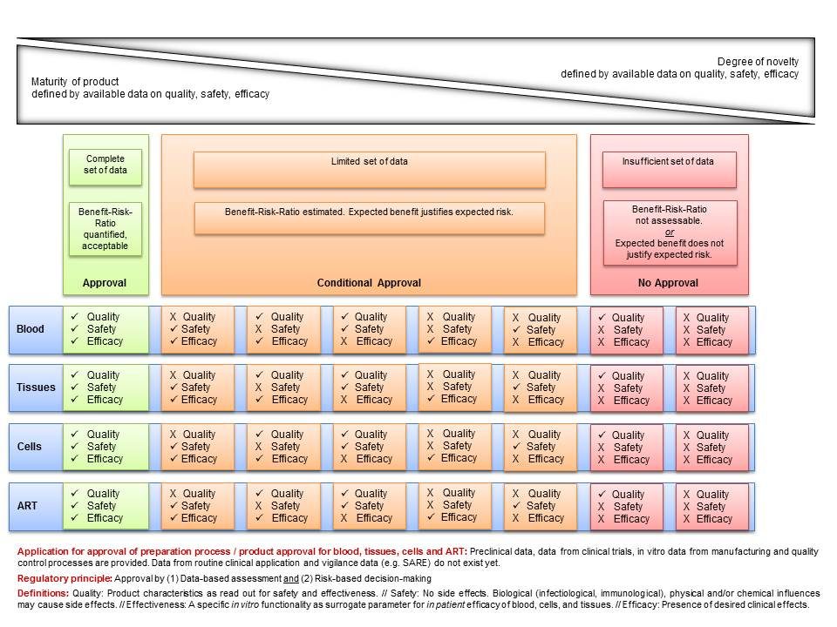
Figure 2: VISTART WP5B algorithm.

VISTART also proposes a classical risk calculation model that shall be performed by BTEs. The assessment of the risks related to a novelty should address the following aspects:
- Identification of the hazards.
- Risk Assessment: an estimate of the probability that the hazards occur and the severity of the consequences for patients if it occurs. The likelihood that hazards can be detected can also be taken into account.
- Risk evaluation: establishing the level of risk involved with the novelty and the need to mitigate the level of risk for patients.

A tool to perform risk assessment was developed also by EUROGTP project, and a revision of this tool as well as the risk assessment methodology will be done in the next point of this deliverable.

One of the outcomes of VISTART project is the classification of the different risk levels and also what is the CFUp that should be performed for each risk level.
On the following chart there is a classification of the different risk levels and also the type of clinical follow-up for each level.

Risk levels | Type of clinical follow-up plan
Negligible risk | Standard vigilance procedure should be in place and verified to be in compliance with the EUTCDs/EUBDs SARE reporting requirements.
Low risk | Negligible risk criteria apply.  Appropriate recipient’s clinical progress should be documented by the physician as foreseen in normal clinical practice.  In addition, a clinical follow-up plan has to be established that monitors the patients regularly. Results to be reported by the clinician to BE/TE and/or CA should be specified.  A periodic review of pertinent literature has to be undertaken with results to be summarized and to be submitted to the BE/TE and/or CA.
Moderate risk | Low risk criteria apply.  The clinical follow-up plan should be designed to specifically consider potentially critical clinical side effects. These should be monitored through a defined typology/frequency of controls. They should where possible fit into the standard medical practice.  The clinical follow-up study should be supplemented where possible by registry data, if possible at a European level.
High risk | Moderate risk criteria apply.  Systematic collection of safety/effectiveness results through observational or clinical trials, according to GCP principles. Protocol designed to detect unidentified risks and reduce level of uncertainty /lack of knowledge, if applicable compared to standard therapy.
Table 1: Risk level and associated CFup

Inspection guideline

The VISTART project also developed ‘Inspection Guidelines for EU Competent Authorities responsible for the inspection and authorization of blood and tissue establishments’⁴. The aim of this document is to provide competent authorities with a common framework for conduction of inspections of blood and tissue establishments.
This guideline contains the different procedures for authorizing activities as well as to renew or authorize amendments to existing licences.
After an inspection is performed, as it was shown in the figure 2, there can be three results for the authorization application: approval, conditional approval and refusal of the approval.
The inspection guideline also shows the criteria to renew the authorizations and how to proceed to authorize modifications of the procedures. This information will be useful for the Overall Guidance in GAPP project.
The VISTART inspection guideline also includes a chapter regarding the General Governance and Quality Management Principles for Competent Authorities. The main principles included in the VISTART project are:
- Administrative Structure.
- Independence and Impartiality.
- Quality Management.
As an objective of the guideline of WP5 is to define organisational models and mandates of the CAs responsible for the PPA and the optimal composition of the assessing team in the CA, along with defining the definition of the inspector’s involvement, the principles of the inspection guidelines may be reviewed and included in the WP5 guideline.

II. EUROGTP II

Introduction

Good Practices for demonstrating safety and quality through recipient follow-up (EUROGTP II) ⁵ is a three year Project, founded by the European Union under the Grant Agreement number 709567. It was coordinated by the Barcelona Tissue Bank of the Blood and Tissue Bank (BST). 14 Associative partners from 11 Member States and 12 Collaborative partners also took part in the project.
The main objectives were:
- Develop common Good Practices for European Tissue Establishments and Organisations Responsible for Human Application, that address the studies extent (retrospective, concurrent, prospective and short and long term) needed for human application of the tissues/cells in a safe and effective manner:
  - Determining methodologies for assessing the risks associated to novel tissues/cells;
  - Determining methodologies for assessing the extent of the studies needed to provide enough quality, safety and efficacy data for the use of tissues/cells;
  - Determining the follow up programs, according to the inputs of the previous issues, to ensure safety and support the evaluation of the clinical efficacy
- Develop a database of products, preparation procedures, clinical applications and follow-up programs, and their current status of authorisation and implementation (established/validated; validation studies in progress; discarded for clinical application.
- Propose a GTP’s Management Model foreseeing future update, promotion and harmonization of GTP’s standards, and the implementation of accreditation and training programmes at European level.
The project had nine WP:
- WP1: Management of the project.
- WP2: Dissemination.
- WP3: Evaluation.
- WP4: Coordination.
- WP5: Generic Good Practices for demonstrating safety and quality through recipient follow-up.
- WP6: Good practices for demonstrating safety & quality through recipient follow-up in Tissue.
- WP7: Good practices for demonstrating safety & quality through recipient follow-up in Hematopoietic Stem Cells.
- WP8: Good practices for demonstrating safety & quality through recipient follow-up in ART.
- WP9: T&C Database and interactive assessment tool.
The main outcomes of the project were:
- A Guideline of ‘Good Practices for evaluating quality, safety and efficacy of novel tissue and cellular therapies and products’. It provides the way to use the systematic risk-based tool to:

  - Evaluate if a new or changed TCTP has significant novelty.
  - Determine the overall risk arising from the novelty.
  - Determine an appropriate level of pre-clinical and clinical evaluations to address and assess the risk.
  - Implement the result of risk assessment into routine practice and follow up the results.
- An interactive Assessment tool to measure the risk for tissues, cells and ART. It contains an algorithm to assess the need of extended studies and follow-up programs needed to implement, evaluate and authorise a novel tissue and cell product, process or therapy.
- A tissue and cells database of products, process and therapies, their authorisation and implementation status and relevant associated biovigilance data.

Novelty

EUROGTP II project gives a definition of Novelty⁶. It is defined as ‘any change that could significantly affect the quality and/or safety of the tissue and cellular therapy/product (TCTP) and/or the safety of the recipients.’
One of the outcomes of the project is a tool to evaluate if a TCTP is a novelty, how to evaluate it and an analysis of the risk level. For that, they propose the following steps:
- Previous steps.
- Evaluation of the novelty (Step 1).

Previous steps

The EUROGTP II Guide suggests that before the assessment of the novelty and the associated risk it is important to characterize the TCTP. It is proposed to describe and gather the following information:
- Justification for the implementation of change.
- How is the TCTP prepared?
- What is the origin of the TCTP?
- In what format is it presented?
- What, if any, excipients or other reagents or residues could be transferred through the clinical application with the TCTP.
- What are the critical process parameters applied to the TCTP preparation protocol?
- What are the critical quality attributes necessary for the TCTP to deliver its intended result?
- What clinical indication is the TCTP to be used for?
Also, before the implementation of changed or new processes, it is recommended to review the following information:
- Existence of prior clinical data reported by other centres (if applicable).
- Quality control measures and any other quality indicators evaluated.
- Overview of the intended clinical effect of the TCTP.
- Bibliographic evidence that supports the implementation of changes.
- In house data generated to justify the process.

Evaluation of novelty

Evaluation of novelty is the first step. EUROGTP II proposes to fill in the following chart to assess the novelty. These questions cover the whole process, from the donation to the clinical application of the tissues or cells. If no novelty is identified, it can be concluded that there is no significant change or innovation in the TCTP that is being assessed.
 | YES | NO | NA
Has this type of TCTP previously been prepared and issued for clinical use by your establishment?

Will the starting material used to prepare this TCTP be obtained from the same donor population previously used by your establishment for this type of TCTP?

Will the starting material for this TCTP be procured using a procedure used previously by your establishment for this type of TCTP?

Will this TCTP be prepared by a procedure (processing, decontamination and preservation) used previously in your establishment for this type of TCTP?

Will this TCTP be packaged and stored using a protocol and materials used previously in your establishment for this type of TCTP?

Will this type of TCTP provided by your establishment be applied clinically using an implantation method used previously?

Has your establishment provided this type of TCTP for implantation or transplantation into the intended anatomical site before?

Table 2: EUROGTPII questions in relation to novelty

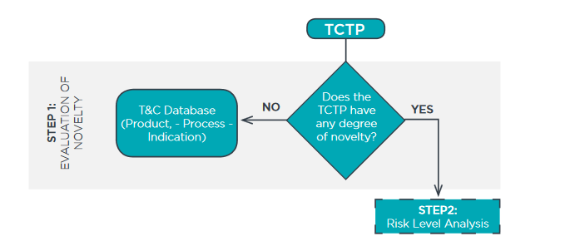
Figure 3: Evaluation of Novelty from EUROGTP Guide.

Risk assessment

If after step 1⁶, evaluation of novelty, it is established that there is a new TCTP or a change in a TCTP, EUROGTP proposes to perform a systematic risk-assessment to identify and quantify the risks associated with it.
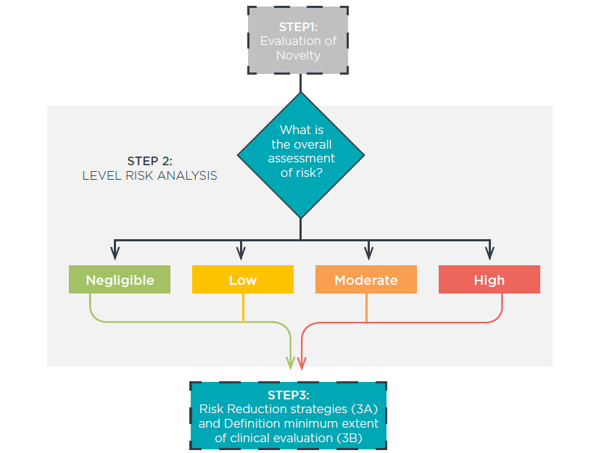
This risk assessment should consider all aspects of the process: donor selection, procurement, processing, storage, transport, product and clinical application procedures. This is considered the second step of the novelty and risk evaluation process.

Figure 4: The risk assessment process from the EUROGTP II Guide.
In order to perform the risk level analysis, it is necessary to identify potential risk factors and risk consequences. Each of them must be individually assessed to determine the residual risk of implementing the change. For that, according to EUROGTP Guide it is necessary to consider:
- The probability of the risk occurring.
- The severity of the consequences should the risk occur.
- The probability that the source of the hazard for the risk consequences will be detected before the TCTP is applied. This does not refer to detection of the consequences of the risk post implantation.
- Any existing evidence that can be used to mitigate the risk.
This exercise, that shall be performed using the risk assessment tool, gives a Final Risk Score that can be used to inform the definition and extent of pre-clinical and clinical evaluation, necessary to support the proposed novelty or change.

Definition of studies extent

The Final Risk Score determined on Step 2, determines the corresponding extent of studies required to ensure the safety and efficacy of the TCTP, in terms of the pre-clinical and clinical evaluation. The Guide proposes specific methodology of tissues, Hematopoietic Stem Cells (HSC) and Assisted Reproductive Techniques (ART).
The definition of studies extent is the third step. And it consists of two sub steps:
- Step 3A: risk reduction strategies: using pre-clinical studies (in vitro and in vivo) to mitigate the identified risks.
- Step 3B: Extent of clinical evaluation.

Risk reduction strategies
After performing the risk assessment⁶, it can be considered, according to the risk score, that his can be mitigated by performing preclinical studies. According to the EUROGTP Guide, if the initial risk is negligible then no further studies may be needed. In case the risk is low, moderate or high, it might be possible to perform additional preclinical studies if these have not been done already to mitigate and reduce the level of risk prior to clinical application.
The guide proposes the following risk reduction strategy for each risk level:
- Negligible: The assessment indicates that the TCTP is safe and efficacious for clinical use and very unlikely to cause harm to recipients, however, it may be advisable to conduct a validation of the process, if not already done. If the nature of the risk is not related to the process itself, the requirement for validation may not apply, for example where the novelty is in the method of clinical application.
- Low: The assessment indicates that the TCTP is safe and efficacious for clinical use and unlikely to cause harm to recipients, however, a validation of the process, if not already done, should be performed. If the nature of the risk is not related to the process itself, the requirement for validation may not apply, for example where the novelty is in the method of clinical application.
- Moderate: The assessment indicates that more evidence is needed to support safe and effective use of this TCTP and mitigate risk. Process validation should be performed, however if the nature of the risk is not related to the process itself, the requirement for validation may not apply, for example where the novelty is in the method of clinical application. Pre-clinical in vitro evaluation studies, specific to the identified risks, should be performed if not already done. Pre-clinical in vivo evaluation using an animal model should be considered if applicable (and if not already done).
- High: The assessment indicates that significantly more evidence is needed to support safe and effective use of this TCTP and mitigate risk. Process validation should be performed, however if the nature of the risk is not related to the process itself, the requirement for validation may not apply, for example where the novelty is in the method of clinical application. Pre-clinical in vitro evaluation studies, specific to the identified risks, should be performed if not already done. Pre-clinical in vivo evaluation using an animal model should be considered if applicable (and if not already done).
The guideline also provides specific risk reduction strategies for tissues, HSC and ART.

Risk reduction strategies

EUROGTP II defines clinical evaluation⁶ as clinical follow up studies for monitoring predefined clinical outcome indicator(s) to evaluate quality, safety and effectiveness/efficacy of tissue or cell product for a defined number of patients.
It is proposed to perform these protocols when risk cannot be mitigated to ‘negligible’ or ‘low’ levels by in vitro or pre-clinical studies, and when ethically accepted, clinical evaluation protocols may be necessary before the TCTP is made generally available.

The project proposes the following extent of studies for each risk level:
- Negligible: No clinical follow up over and above what is the mandatory requirement, such as serious adverse reaction and event (SARE) reporting.
- Low: In addition to the mandatory requirement for serious adverse reaction and event (SARE) reporting, feedback from immediate post clinical application monitoring (routine clinical follow up) may be collected for a defined period or number of procedures. Clinical audit may also be used after an appropriate period of use.
- Moderate: A structured plan for active collection of a specific set of data relating to the safety and efficacy of the TCTP should be put in place, in addition to routine clinical follow up. Ethical approval may be required and the principles of Good Clinical Practices adhered to. Consideration should be given to restricting provision of the TCTP to a limited number of patients and/or centres until the risks have been adequately mitigated.
- High: The TCTP should only be used clinically in the context of an ethically approved, controlled (where applicable) clinical evaluation until the residual risks have been adequately mitigated. The principles of Good Clinical Practices must be adhered to. Clinical evaluation and follow up programs should be implemented and safety and efficacy must be continuously monitored. If available national and international registries are recommended for gathering follow up data.

Specific clinical evaluation for tissues, HSC and ART are also defined in the Guide.
On the following figure, the whole risk assessment process, described in EUROGTP is explained:
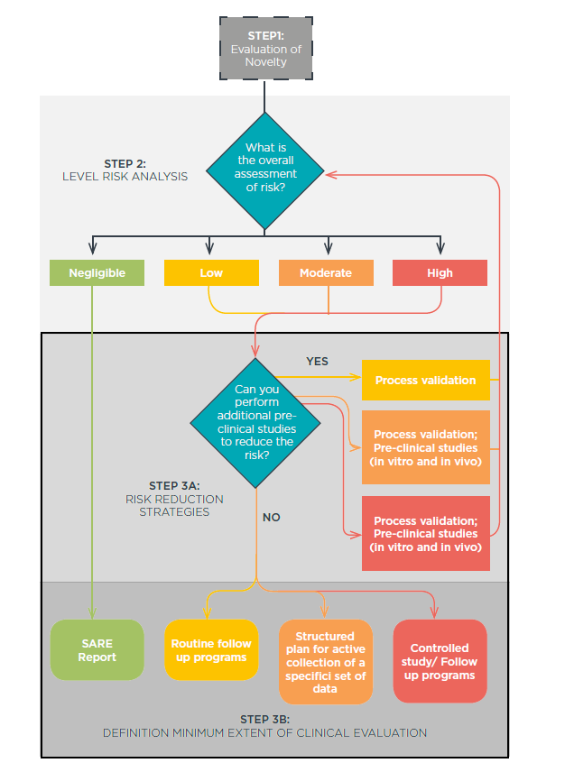
Figure 5: The risk reduction and determination of the extent of studies required.

Blood.

The EUROGTP tool is only designed and tested for tissues, HSC and ART, but not for blood and blood components. As EUROGTP is a known tool by the CA and the TE, adapting it to blood would be really useful. By adapting EUROGTP to include blood and blood component, there would be only one tool to assess the novelty and the risk for blood, tissues and cells.

IV. EECTR

ECCTR⁷ is the acronym for the European Cornea and Cell Transplantation Registry. It is a project founded by the European Commission, and it was led by the European Society of Cataract and Refractive Surgeons (ESCRS). EECTR project began on May 2016 and finished three years later. There were 8 partners
The main objective of EECTR is to build a common assessment methodology and establish an EU web-based registry and network for academics, health professionals and authorities to assess and verify the safety, quality and efficacy of corneal transplantation.

There were 7 Work Packages
- WP1: Coordination.
- WP2: Dissemination.
- WP3: Evaluation.
- WP4: Development of the software for the common Europe-wide platform.
- WP5: Active clinical cooperation % networking with VISICORT.
- WP6: Data collection, recruitment of clinics across Europe.
- WP 7: Evaluation of data collected & development of evidence based European protocol.
The specific objectives of the project were:
- To develop and test an EU web-based registry, for assessing and verifying the safety quality and efficacy of human donor tissue transplantations in ophthalmology.
- To roll out the system across Europe, involving eye banks and clinics in the collection of data and establishing interfaces with the existing registries in Europe. Promote registry at European level and encourage participation by all European transplant centres
- To analyse the safety, quality and efficacy of ophthalmic donor tissue transplantations, including a novel tool for patient reported outcomes.
- Strengthen the knowledge concerning adverse immune reactions through active cooperation with EU funded projects Arrest Blindness and VISICORT on the definition and validation of parameters for clinical application within the European Cornea and Cell Transplantation Registry
- To collect data on the need and availability of human donor tissue for transplantation in Europe to allow academics, health care professionals and authorities to optimize scarce donor tissue allocation
- To provide a pan-European overview of current clinical practice to support development of benchmarks and guidelines regarding the safety, quality and efficacy of ophthalmic transplantation therapies.
- To disseminate the results of the evidence based European protocol on the benefits to researchers, professional practitioners, competent authorities and the wider community.

Data Base

An Electronic Data Capture (EDC)⁸ platform has been developed by EETCR. The registry records data related to the donor, transplant procedure and the recipient as well as a two-year follow up. The data included in the database is as follows:
- Recipient data: ID, data, year or birth, gender
- Donor data: ID, donor age, gender
- Cornea bank: Bank ID.
- Tissue details: SEC, Site Tissue ID.
- Processing details: donor endothelial cell density, time in storage, storage medium, further eye bank processing.
- Surgery details: Site Surgery ID, surgery date, date on waiting list, surgery type, and surgery combined procedures, surgery complications, surgeon experience.
- Eye details: eye laterality, first transplantation on eye, original diagnosis first transplant, indication for transplant, transplant indication infection type, main reason for transplant, risks factors including ocular comorbidity, distance corrected visual acuity, distance corrected visual acuity of the fellow eye.
- Follow- up details: lost to follow-up, follow-up date, follow-up complications, use of corticosteroids or other immunosuppressant, sutures still existing, spherical retraction operated eye, cylinder retraction operated eye, axis retraction operated eye.
- Fellow eye follow-up details: spherical retraction fellow eye, cylinder retraction fellow eye, axis retraction fellow eye.
- Graft failure details: graft failure date, graft failure code, graft failure details.

V. Conclusions

- There should be common terminology. VISTART refers to BTC-PP/product, which means Blood Tissue Cell- Preparation Process or Product. Meanwhile, EUROGTP refers to TCTP, tissue and cell therapy product. There should be only one terminology for all the Member States to facilitate the implementation and to have the same framework.
- VISTART principles should be the base of the Overall Guidelines specifically the first and the third principles. The first being, remarking that the quality and safety of the BTC product has to be ensured by an assessment based on comprehensive data of BTC-PP/product authorization requests and by risk-based decision making on approval of BTC-PP/product authorization. The third specifies that if the expected benefit outweighs the expected risk, a conditional authorization for the PP/product may be issued. This principle also says that a conditional authorization may be based on an adequate CFUp study plan, approved by the Competent Authority.
- To begin the authorisation of a new process or a change in a procedure, evaluation of novelty must be performed. The risk assessment developed by EURGTP should be used as the first step EUROGTP is a well-known tool that will provide different Member States a common way to assess the risk as well as the subsequent actions to take according to the level of risk. And this procedure will also meet the first VISTART principle.
- The risk categorization described in VISTART and EUROGTP might be used for determining the different steps to follow to authorize new products according to the risk level. Requirements for each level of risk should be described and established on the Overall Guidance.
- The Guidance should also contain the possibility of issuing a conditional authorization, however the requirements for it should be established along with the different criteria of the CFUp, for BTEs and CAs.
- Seeking the possibility of adapting EUROGTP for blood should be considered.
- The definition of novelty provided by EUROGTP can be used as a basis in order to define a significant change in preparation process that is one of the objectives for WP5 in the GAPP project.
- The VISTART inspection guideline should be taken into account in order to develop the GAPP Overall Guidance, especially the criteria for the Competent Authorities and authorisation.
- The risk reduction strategies and the extent of clinical evaluation described in the EUROGTP tool would be considered in the PPA as well as in the CFUp.
- EECTR registry and the items they gather can be also helpful for elaborating the requirements for CFUp.

Acronyms

ART Assisted Reproductive Techniques
BE Blood Establishment
BTC Blood, Tissue and Cell
CA Competent Authority
CFuP Clinical Follow-up Plan
ECCTR European Cornea and Cell Transplantation Registry
EUTCD European Tissue and Cells Directives
EUBD European Blood Directives
EDC Electronic Data Capture
EU European Union
EUROGTP European Good Tissue Practices
HPRA Human Product Regulatory Authority
HSC Hematopoietic Stem Cell
GTP Good Tissue Practices
ID Identification
MS Member State
OCATT Catalan Transplant Organization
PP Preparation Process
PPA Preparation Process Authorization
SARE Serious Adverse Reactions and Events
SEC Single European Code
TCTP Tissue Cell Therapy Product
TE Tissue Establishment
VISICORT Improving Immune System Response for Corneal Transplantation
VISTART Vigilance and Inspection for the Safety of Transfusion, Assisted Reproduction and Transplantation
WP Work Package

References

1 VISTART web site: https://vistart-ja.eu/ Last access 7th August 2020. The Join Action VISTART. GA 676969.

2 Principles for Competent Authorities for the evaluation and approval of clinical follow up protocols for blood, tissues and cells prepared with newly developed and validated processing methodologies. VISTART Deliverable 5.4. May 16, 2018. The Join Action VISTART. GA 676969.

3 VISTART- WP5 part B questionnaire en new products/processes and clinical follow up. April 27, 2016. The Join Action VISTART. GA 676969.

4 ‘Inspection Guidelines for EU Competent Authorities responsible for the inspection and authorization of blood and tissue establishments’. The Join Action VISTART. GA 676969.

5 EUROGTP web site http://goodtissuepractices.eu/ . Last access 7th August 2020. The EUROGTP II project. GA 709567.

6 EUROGTP II Guide: Good Practices for evaluating quality, safety and efficacy of novel tissue and cellular therapies and products. http://www.goodtissuepractices.site/docs/EuroGTP_II_Guide.pdf . Last access 7th August 2020. The EUROGTP II project. GA 709567.

7 EECTR web site https://www.ecctr.org/. Last access 7th August 2020. The EECTR Project. GA 709723.

8 EECTR Data base web site. https://ecctr.net/Home/Index/Login . Last access 7th August 2020. The EECTR Project. GA 709723.

